Umeed Partnership Pakistan (UPP)
(Developing communities through education and training)
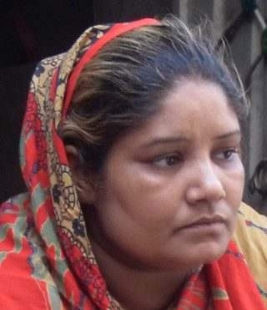
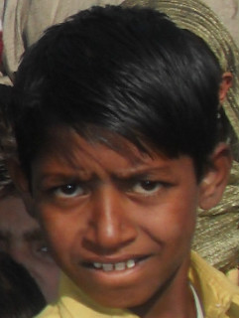
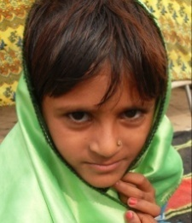
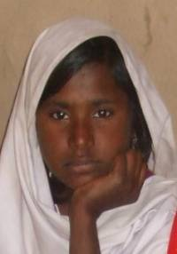
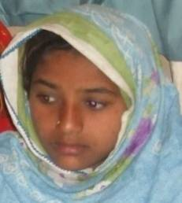
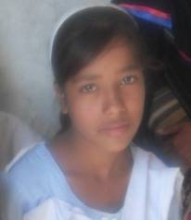
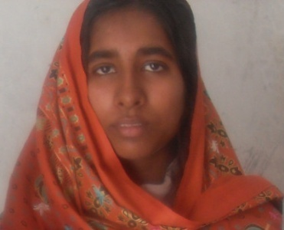
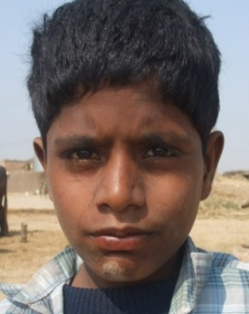
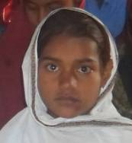
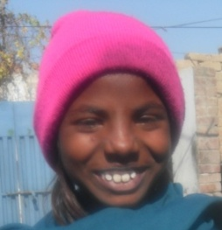
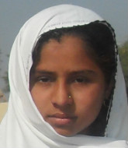
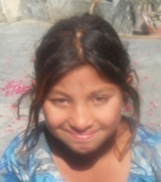
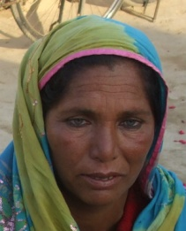
Trustees: The premises at 8 S

Registered Charity # Pk. 764 and UK 1087846

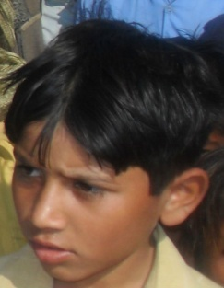

Umeed Partnership Pakistan (UPP)
House # 198/199, Block J-3, M.A. JOHAR TOWN,
LAHORE, PAKISTAN
TELE: 0092 35957302, CELL 0092 300 9444482
E-MAIL: umeedpartnershippakistan@gmail.com
Yousufjalal22@yahoo.com

Annual Report
2012/13

UMEED ADMINISTRATION AND PROJECTS

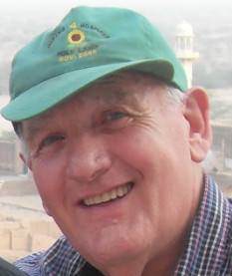
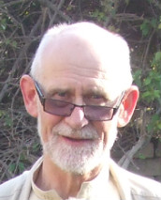

Education

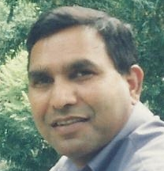

Democracy

Legal Aid Forum

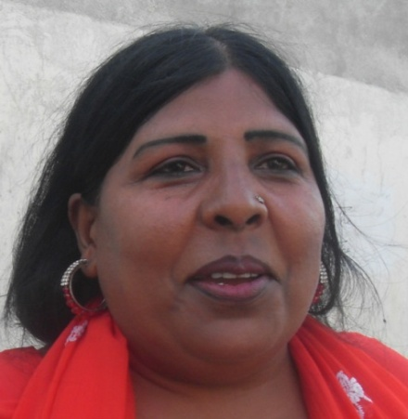
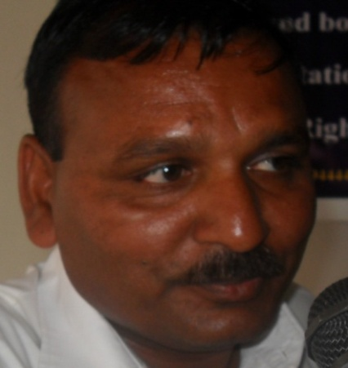

Human Rights Training

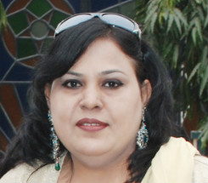

Street Theatre

Sports Club

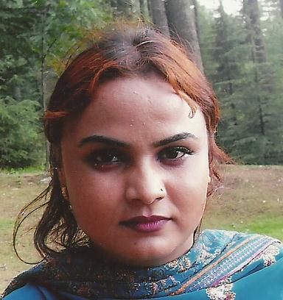
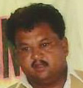

Skill Training

Umeed Partnership Pakistan (UPP) has a non-political, non- profit ethos, registered under Societies Act 1860 and is entitled to work nationwide. Umeed is also registered as a charity in the UK. Umeed in the recent past has emerged as a humanitarian organization committed to work for Development and Human Rights promotion. The Organization has its Head office in Lahore along with three regional offices in Loralai, Bahawalpur and Lahore. The Umeed Project is managed by an executive board.

The Umeed Partnership exists to provide opportunities through education and training to vulnerable and disadvantaged girls & women, and boys & young men, in diverse parts of Pakistan. The organization is multi-faith and is operational in the tribal communities of Baluchistan, in slum districts of Lahore and in the marginalized low-caste dalit communities of Cholistan Desert in southern Punjab. The organization is also evolving into a women’s support body to support victims of widowhood, disease and domestic violence.
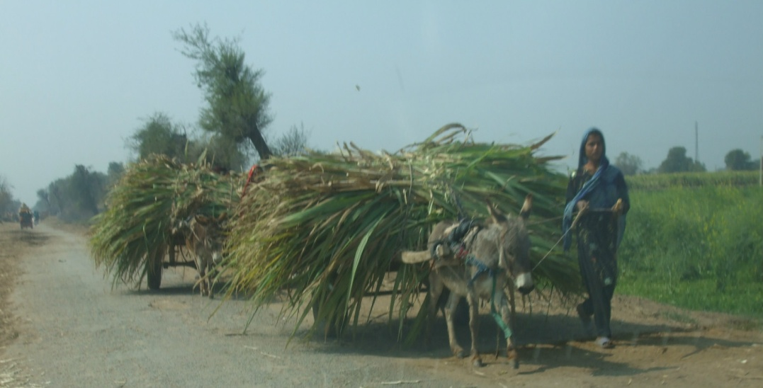
Basic education is offered together with embroidery and tailoring for girls and women, carpentry and woodturning skills training for street boys in the Cholistan Desert and Lahore. Also to empower women and street children through human rights training. Seminars and workshops are conducted during the year in different regions. For children, two mixed faith Middle Schools have been opened in marginalized ‘dalit’ communities near Bahawalpur and Yazman in the Cholistan Desert.

Umeed is committed to work for the socio-economic rights and promotion of human rights and democracy amongst the masses irrespective of caste, creed or gender. Umeed works to break the unjust structures prevailing in Pakistani society. It works at grass-roots level with all those who believe in human liberation and who have committed themselves for this worthy cause.

Vision:
The vision of UPP is to see an educated, skilled and talented youth, with improved equality
between men and women, liberated from landlords’ bondage.

Mission:
- To reach out to those who lack basic human needs with the aim of restoring dignity and respect irrespective of caste, creed or gender.
- To promote basic Human Rights and democratic processes within oppressed communities.
- To provide opportunities to youth to improve their talents, abilities and leadership qualities.

Goal: To promote and facilitate formal and informal education at all levels.

Umeed’s Focal Sectors include:

Human Rights:
- Human Rights and democratic education
- Empowerment of women and elimination of gender disparities
- Capacity enhancement of women’s’ groups and civil society organizations
- Research and documentation

Development:
- Promotion of entrepreneurship and development of small business skills
- Formal and non-formal education
- Socio-economic empowerment of the poor
- Assisting women in distress through free legal aid

MESSAGE FROM THE CHAIRPERSON OF UMEED (UK) - Dr. John Perkins

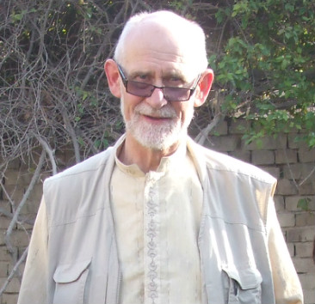
Umeed Partnership Pakistan has sustained its activities during 2012/13, and this is despite Pakistan’s well-documented but negative media image which has intensified following several high-profile acts of violence. It is true that Pakistan is experiencing political instability, but as I’ve emphasized in previous reports, life for the large majority of the population continues largely unaffected by the troubles. The Umeed Partnership continues its activities in all parts, and has been untouched by the events reported in the media.
The mission of the Umeed Partnership is unchanged. That is, it provides education and vocational training at grass roots level, leading to employment opportunities, for disadvantaged girls and women and street children of all faiths and cultures in Pakistan. To empower women and street children, human rights training, seminars and workshops are conducted during the year in different regions. For children two Umeed Middle schools have been opened in marginalized ‘dalit’ communities near Yazman in the Cholistan Desert. Umeed is committed and dedicated to work for the socio-economic rights and promotion of human rights and democracy in all communities. Through the Umeed Legal Aid Forum free legal aid is provided for women victims of crimes.
The recently formed Umeed Street Theatre and Umeed Sports Club have succeeded in realising the potential of young people who would have otherwise been outcasts in their communities .
UPP activities continue to be concentrated in three diverse areas of Pakistan, viz Quetta and Loralai cities in Baluchistan; the Yohannabad slum communities of Lahore; and low-caste Hindu communities in southern Punjab, centered in Yazman and in Bahawalpur District on the margins of the Cholistan Desert.
Yousuf Jalal Gill coordinator UPP visited North Wales in June/July 2012 and he spent three weeks raising awareness of the Umeed Project across North Wales. Thanks are due to all those who gave him such a warm welcome. A very full program was devised which included meetings with Bishops, MPs, AMs, schools, churches, university departments, community groups and Rotary Clubs.
News of the appalling shooting of Malala Yousufzai as punishment for her demand for education for girls in rural Pakistan has brought the situation of women in that country into sharp focus. In an overwhelmingly male-dominated society, women may be seen by some as sub-class citizens where illiterate women are denied basic human rights. Malala believes that only through education can women and girls achieve equality with men in their society and so contribute to the well-being of their communities and nation. This has been precisely the mission of the Umeed Partnership over the last 12 years, and there is ample proof of this in the communities where Umeed has been working.
The Umeed Partnership really does make a difference to people’s lives, and I get quite a buzz out of being part of it. Time and time again I have come across young women and street children of all faiths who have received training in the Umeed Skill Centres over the past ten years, and who are now making a living for themselves and their families, bringing home up to Rs7000 per month – a very respectable sum in the rural desert communities. Some have become trainers themselves, and so this is an example of the Project becoming self-sustaining.
The Umeed Schools also have provided a lifeline for uneducated communities in southern Punjab; they are a credit to the dogged determination of the UPP team to improve opportunities in these impoverished communities. So, to conclude, the Umeed Partnership is demonstrably improving the quality of life for women, children, families and communities. In addition to skills training and education, Umeed is evolving into a support network for vulnerable women who may be victims of domestic violence, illness and bereavement. Due to its multi-faith ethos, Umeed also encourages dialogue, and hence reconciliation, between the major faith groups. In our world of fragile international relationships, Umeed is surely a cause to celebrate and support.
My thanks are due to all who have supported the Umeed Partnership Project over the year, and in particular the UPP committed and dedicated team. I should like to thank especially the individual donors, who must remain anonymous, but who have exceeded expectations in their generosity this year. Of course, we are always pleased to receive donations – the Umeed Project would fail without them – but we also need support in other forms (fund-raising skills, financial management, presentation skills, legal expertise, tools and material, and so on). So, if you have any spare time or spare money, please consider continuing to support the Project in whatever way you can.

Message from the Umeed Coordinator Pakistan – Yousuf Gill

Umeed Partnership Pakistan works among the most disadvantaged communities of Cholistan Desert Bahawalpur, the tribal areas of Balochistan and Lahore slums. Due to illiteracy and poverty these communities contribute to militancy in Pakistan. There is no birth control resulting in very large families and food is scarce. Furthermore, education is beyond the reach of most families. The Muslim religious leaders take the children away to Madrassas (seminaries) with the promise of food and an Islamic education. Ultimately some become terrorists. Unknowingly, these poverty-stricken communities have become hub for militancy in Pakistan.
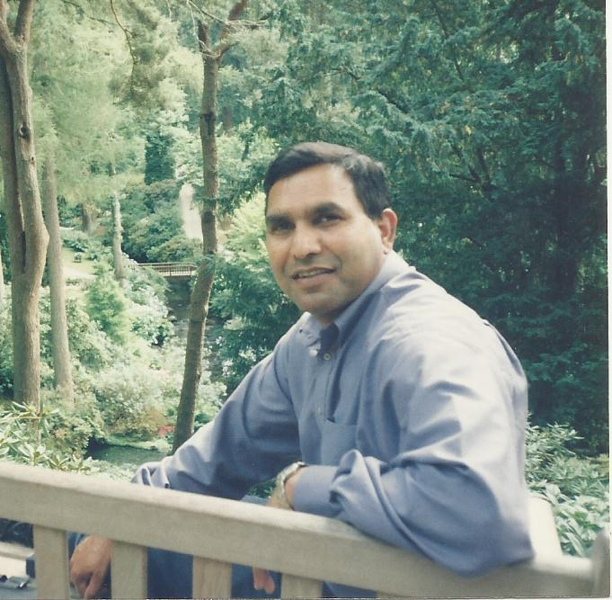
Year 2012-2013 has been destructive for Pakistan. Karachi city remained
on fire throughout the year. There were organized genocides within
the Hazara community (Shea) in Quetta, Balochistan whilst violent
crime against poor people was well-orchestrated and commonplace
in Khaiber Pakhtun Khawa. There have been numerous unlawful
killings in Punjab, thus striking fear into the masses.

Militancy is a day to day problem in Pakistan. Therefore civil
society groups and NGOs have to study the problem
thoroughly and establish their own strategy of working accordingly.
Umeed surveyed these communities and identified the root causes
of militancy, viz poverty, unemployment, poor health, illiteracy and
social and economic inequities. These cause despair, and a
growing sense of deprivation. Umeed is providing answers to all these
problems by providing education to boys and girls, skills training to
girls/women and street children, free legal aid to women in distress,
programs of awareness, mobilization, advocacy and human rights training for
women. Umeed cannot fight militancy directly, but indirectly it is helping people
to better themselves.

My special thanks are due for all those who in different ways supported the Umeed Project during the year. Thanks to UK Umeed Partners for their dedication in their work empowering girls and women. Very special thanks to MM Partners of Netherlands who are providing continuous financial support to promote the cause of the most disadvantaged communities of Pakistan.

Thanks to Rotary International and Rotary clubs (Bangor & Prestatyn), churches (St. Andrew’s) and schools (Prestatyn High School) in the UK; also local and foreign benefactors and supporters and great fund raisers (John Perkins, Stuart Elliot and Clive Southerton) for supporting the Umeed Project with full dedication and commitment. I cannot forget to thank my dedicated UPP team and colleagues, teachers, supervisors, trainers and legal advisors without whose support Umeed Project cannot go forward.

In its spring/summer 2013 edition, the USA-based magazine “The Plain Truth” published an article entitled “Bringing ‘Hope’ to the oppressed” to promote the Umeed Partnership and its activities worldwide. Umeed is grateful to the Publisher and the Editor of the magazine for promoting our most worthy cause in empowering women and street children in Pakistan.

St. Andrew’s Church (Bedford UK) Magazine “The Fisherman”, in its July/August 2013 issue, presented the Umeed Partnership in its outreach report. The report is well written and beautifully presented explaining all the activities of Umeed in Pakistan. Through this report Umeed is being introduced and promoted among the parishioners of St. Andrews. Thanks to the Outreach Committee for supporting (financially) and promoting (publicity) the Umeed Partnership and its activities in UK.

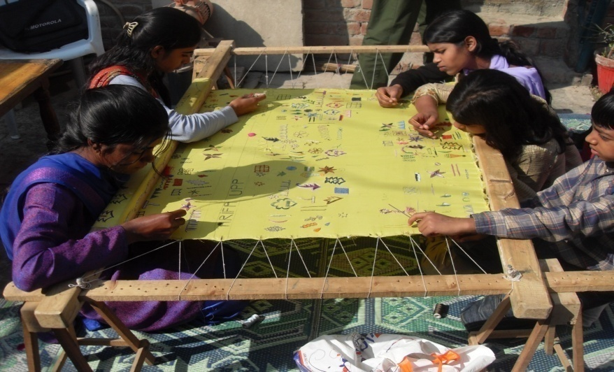
Education and skills training of women are powerful tools against poverty, and for their empowerment. Training has proved that educated and trained women are more likely to be healthier, have higher earnings and exercise greater decision-making power within the household. They are also more likely to ensure that their own children are educated, thus breaking the cycle of poverty and hunger.

After the training, women are economically stronger – this has been noted emphatically by the Umeed staff, who also note that trained women are more hardworking and dedicated than their menfolk.
It is Umeed’s experience that women are often unable to translate their skills into a successful business, and this results in less financial prosperity. Umeed conducts training sessions, helps to cement relationship between women and the market and organizes exhibitions at the regional and national level, These initiatives are advantageous for women’s empowerment.
It is evident that with this project women’s lives are being changed. More children are going to school, health and hygiene systems are improved, and in the recent general election the Umeed provided assistance to women – like vote casting and the right to vote – and thus enhanced the election of the best leaders (including some women).
Umeed provided training and education at their doorsteps to all those women who were not permitted to go outside for training and work. They are now successful trainers and entrepreneurs. In these communities Umeed took into confidence the men who are now convinced of the value of the work of Umeed.
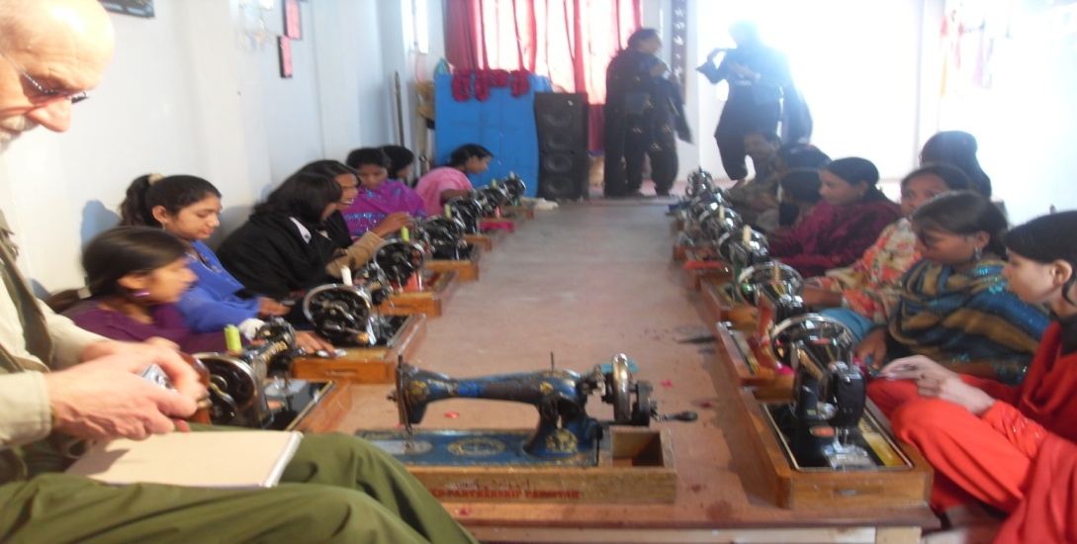
Umeed believes that if women are permitted to train and start businesses, they can create prosperity and better quality of life in their communities. One of Umeed’s current priorities is the dissemination of information about skills trainings and entrepreneurship through print and electronic media, to present successful skills trainers to entrepreneurs.
In 10 of the Umeed Centres, 185 women were trained in embroidery at the professional level. After the training many started their own business and became entrepreneurs; they started their own training centres, became trainers for Umeed and secured respectable employment in NGOs and factories. There are many success stories – here is one of them:

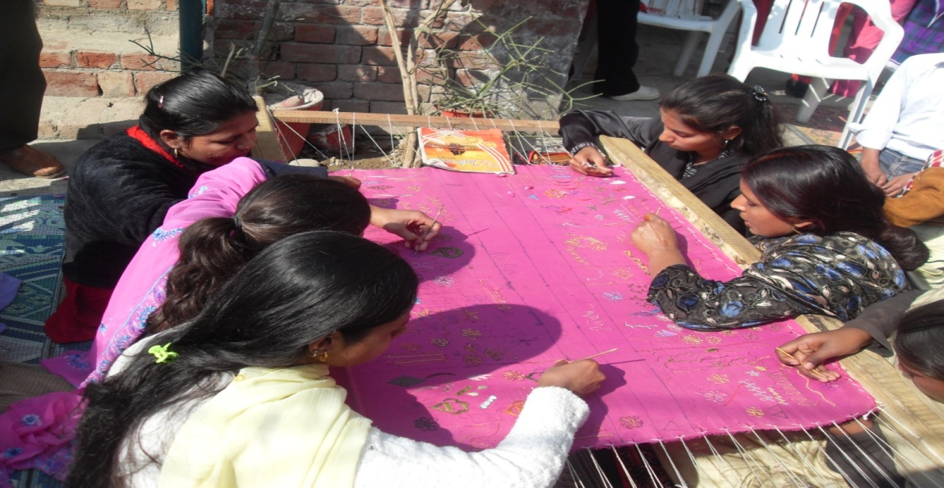
Gull Bibi is a 12 year old girl from a traditional Muslim Pashtun family of Duki district near Loralai in Balochistan. She was allowed to attend school till grade five. Then her education was discontinued and she was asked to stay at home and follow strict veil system in the family. She was not allowed to meet any men, not even her male cousins. As she grew up she realised the unjustness of the restrictions in her life as a young woman. She was very curious about life elsewhere. Gull Bibi had some female cousins in the city who visit her occasionally. She hears stories about city life from them and so she had an urge to make something of herself.

One day a girl from her neighbourhood came to see her. She told Gull Bibi about embroidery Centre being run in their home by the Umeed Partnership. She wanted to join the Centre but her parents would not allow this, fearing that she would be exposed to public view. The trainer of the Centre came to know about the interest of Gull Bibi. She went to see Gull Bibi’s parents and convinced them to send her to centre to learn embroidery assuring them that she would not be exposed to men. Ultimately she was allowed to join the Centre.

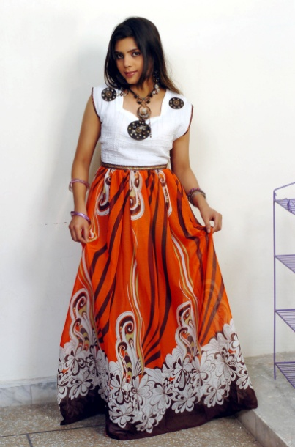
Gull Bibi worked very hard during the year and achieved top position in her class. After a year of training Gull Bibi started producing beautiful dresses for sale. She began to earn enough money. Noting Gull Bibi’s aptitude, her father helped her to establish an embroidery workshop in her house providing training to many other girls. She is now allowed to go to the market and sell her products and purchase material and other necessary things. Gull Bibi now enjoys life because she made the transition from veil to workshop.

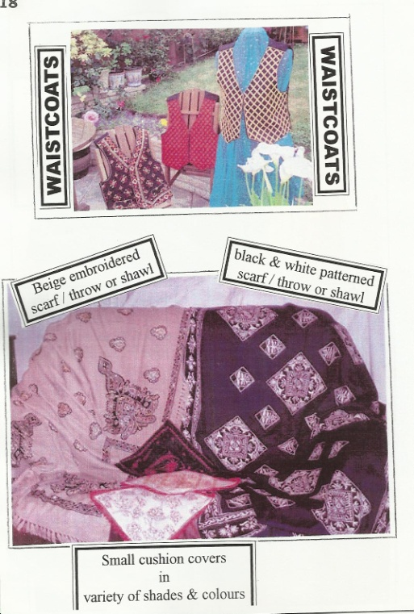

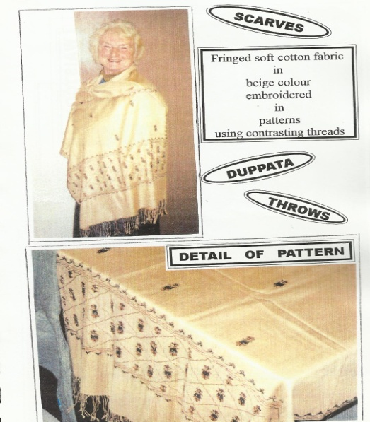
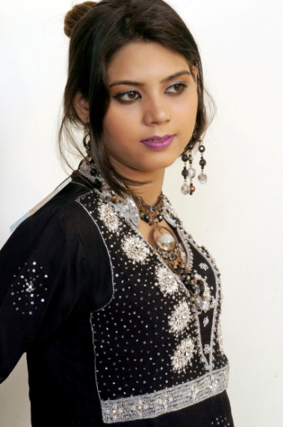

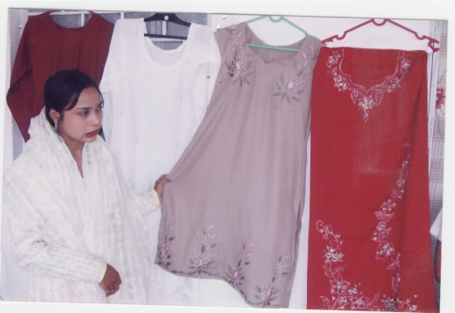

Skills Training for Street Children

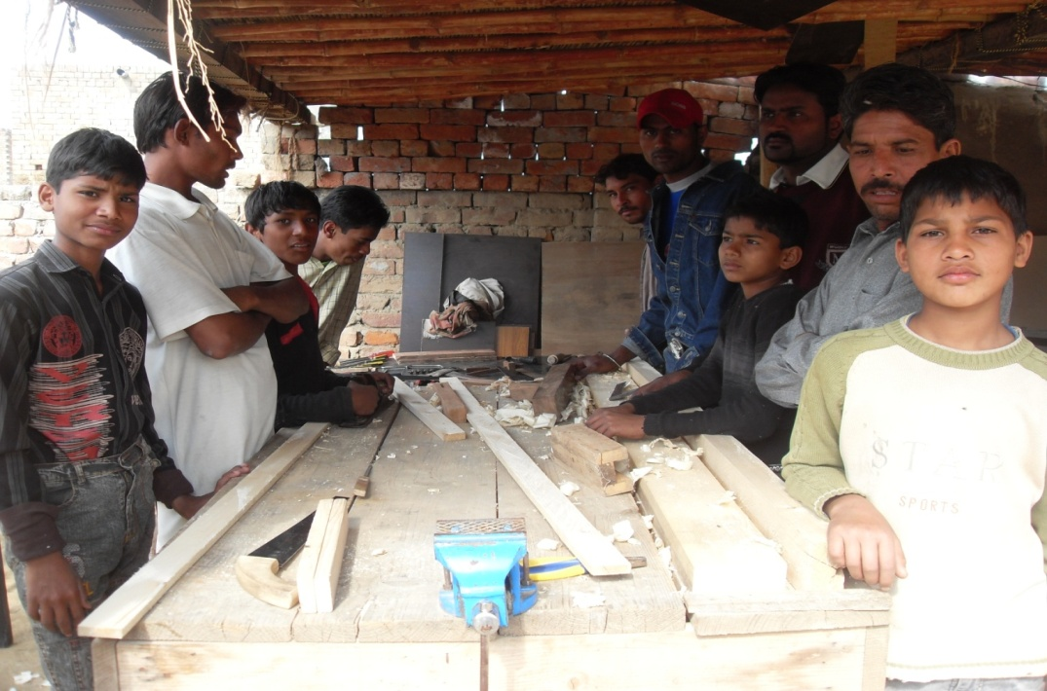
The root causes of poverty in the areas Umeed serves are lack of work and opportunity for economic advancement, as well as a dearth of educational providers. The community as a whole desperately wants to see its children educated and trained, but the government does not provide for this, nor can they afford to provide it themselves. Umeed has been successful in addressing both of these issues by offering training in a skill for which there is a demand both within and beyond their community, and as well, provides basic literacy and numeracy training.

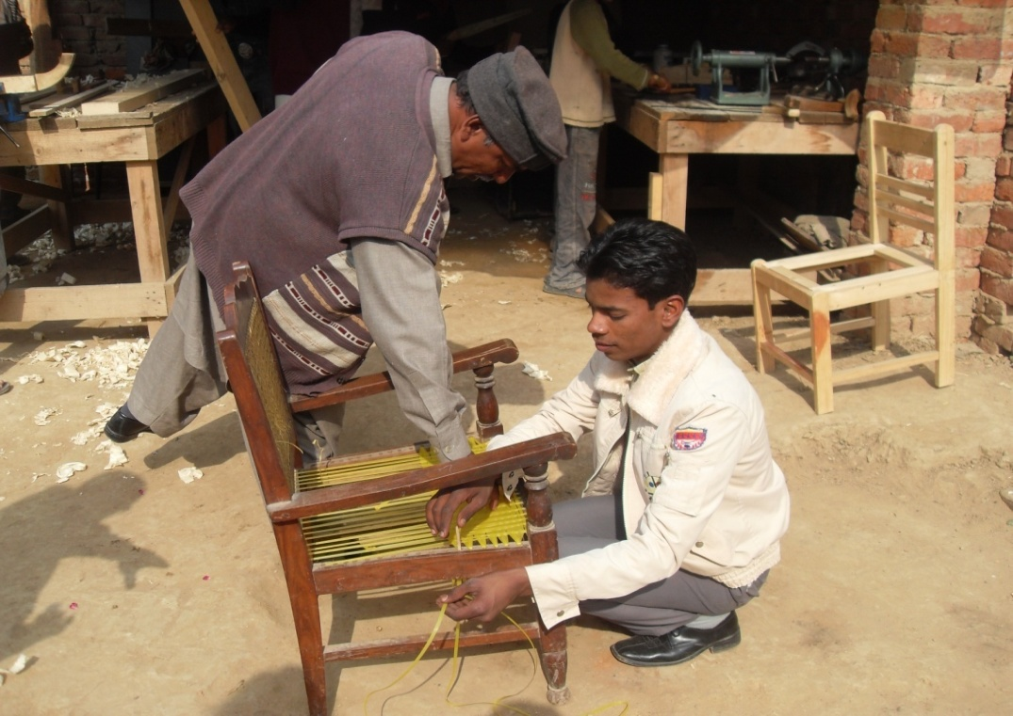
Umeed has a presence in slum communities in Lahore and Yazman, Bahawalpur District. Mostly male children are sent out on the street, or in the fields daily, to fend for themselves and to attempt to earn a wage any way they can. These children are vulnerable to exploitation, not only by the nature of the work that is offered to them, but also by individuals who lure them into prostitution, drugs and other illegal activities. Thus their human rights are at stake. Umeed safeguards their rights by training them in alternative ways of earning a living.

Umeed has responded to a demand for training provision and safeguarding economic rights for street children (mostly boys). Tailoring, embroidery, woodworking and carpentry training centres have been established. Similarly, Umeed successfully provides training in life skills and capacity building skills
"There is no trust more sacred than the one the world holds with children. There is no duty more important than ensuring that their rights are respected, that their welfare is protected, that their lives are free from fear and want and that they can grow up in peace."
Kofi Annan

Three Day Seminar at Lahore Slums Region

UPP conducted a 3-day seminar from 9th to 11th January 2013 at the Korean Community Centre in Yuhannabad, Lahore slums region under the theme of “Women’s Rights and Crime against them.” More than 40 women from all walks of life participated in the program. There were three speakers:

Yousuf Gill - Coordinator UPP

Yousuf encouraged women by saying that they all had the potential to make something of their lives. Women are no less than men. It is culture and discriminatory practices which make women subservient. Most of the crimes committed against women are due to men’s domination over them. Women have to fight against this domination to reduce violent crimes against them.
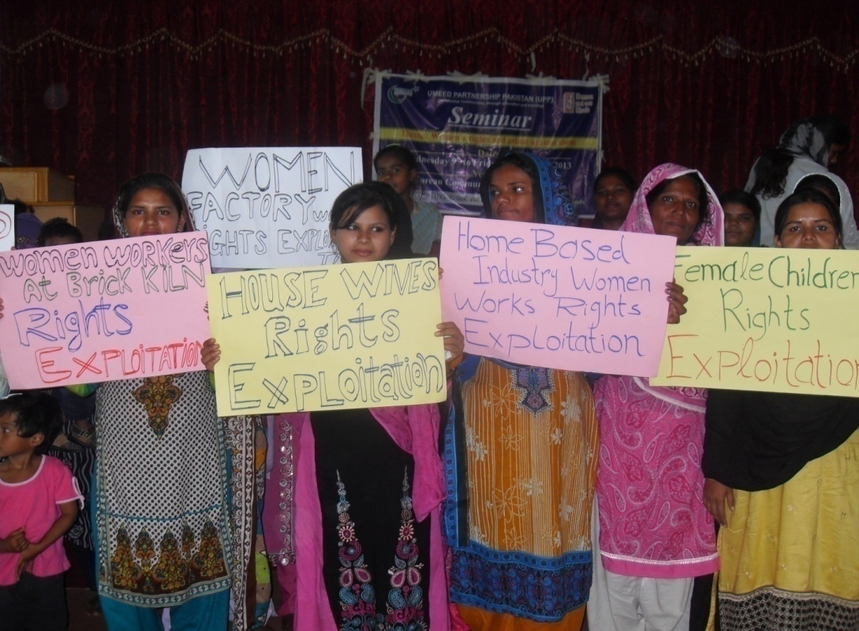

Yousuf said that women throughout Pakistani society are marginalized and oppressed. The media is full of reports of crimes against women - Purdah (forced to cover face); child marriage; acid attack; honour killings; murder of pregnant women; sexual slavery & forced prostitution; rape, genital mutilation – the list is endless. Women are often presented as disloyal persons and vulgar objects worthy of contempt.
The head of a family is usually male. All the decisions are made undemocratically by the male members of the family even in the absence of the head. The opinion of women is not held in respect even in the matters of their own marriages. On the birth of a male baby great ceremonies are held while with the birth of a female baby an atmosphere of a household like that of a funeral prevails. From childhood a male child is given the best food while a girl child is given the left-overs. A male child is considered to have all rights to hold the property of his parents but a female child is left with nothing.
Women feel insecure in this situation; they are insecure while going out of their houses. They are continually fearful of being harassed as they go about their daily and weekly errands, and they are insecure even in their own homes with their own family members who commit domestic violence against them.
Yousuf said that it is fear which prevents women from speaking up to choose their own destiny. Women should take steps themselves to come up in life on an equal footing with men. UPP will be always support women in their struggle to gain freedom and equality. UPP will always be on their side to empower them because Umeed is convinced that “There is no tool for development more effective than the empowerment of women”. (Kofi Annan)

Mrs. Shanaz, Supervisor - UPP Lahore Region

Shanaz said in her talk that the most of the women of slum areas of Lahore are depressed due to the situation they face in their families or at their work places. In both the home and work place they spend their lives as slaves. Women are not given equal rights anywhere in their environment. Due to illiteracy and lack of skills women mostly work as housewives, bearing and rearing children and entertaining their husbands and other family members. They are continuously pushed towards walls and their lives are darkened. They are manipulated at all levels and in the real sense of the word.

Due to abject poverty and illiteracy some of the women go out to do menial jobs at factories, brick kilns, landlords’ homes where they are exposed to every danger and threat. In this scenario women from the minority communities are doubly affected. They are voiceless and easily exploited. The female child is ill-treated at home in these slum communities. They are not allowed education. A boy is preferred over a girl in all matters. A boy is allowed to roam but a girl is confined to the four walls of the house.

Shanaz said that the remedy to these problems is to make women skilful by training them in different trades and helping them to start their own small businesses. They could be given basic education to read and write.

Mariam Francis, Skills Trainer - UPP Lahore Region

Mariam said that in many families women are the sole provider of their families since their men are drug addicted. Women have to go out to earn money by doing menial jobs or even by unfair means getting into prostitution and stealing. They have no professional skills to gain employment. Most of them have the desire to learn skills, become professional and start their own businesses but have no opportunities.

The irony of this situation is that the women meet all the basic needs of their families, yet they are systematically denied their rights of making free choices, access to equal resources, property, education, employment and a marriage of their choice. Two-thirds of Yuhannabad slum areas’ illiterates are female.

Mariam finally said that there is a desperate need to promote women's education, skills training, business and employment with attention to alleviate poverty and illiteracy, halting discriminatory practices, defending women's rights, and improving women's ability to earn and achieve economic self-reliance.

During the seminar Umeed conducted a survey with 200 households living in slums of Youhannabad. The purpose of the survey was to find out the percentage of women working in different sectors and fields. Here are the tabulated results of the survey:

SOMEWHERE WE TURN OURSELVES INTO VICTIMS
INSTEAD OF BEING THE
POWERFUL WOMEN WE
REALY ARE MEANT TO BE

Judith Lioth

House wives 55%

Domestic maids 25%

Factory workers 4%

Brick kiln workers 3%

Employed in other sectors 10%

Home based industry workers 2%

Entrepreneurs 1%

Issues affecting women in the different sectors were also surveyed:
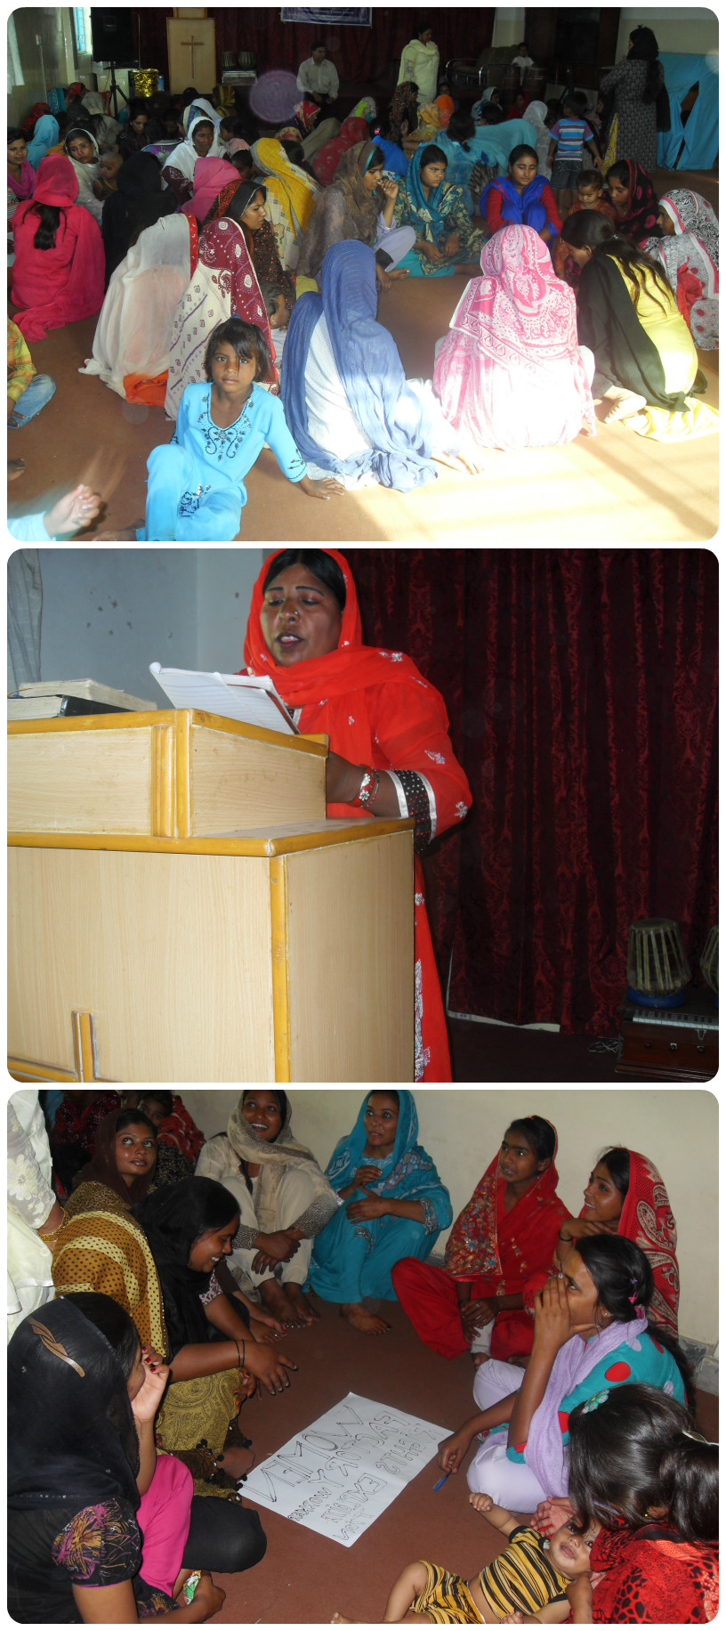
House  Wives | - Drunkard husband  - Domestic torture  - Burdened with work  - No permission to go out  - No permission to work outside  - No permission to meet their relatives  - Bored with routine work  - Daily work not recognized  - No decision making powers  - No share in the family properties or assets
Domestic maids | - Low wages, no fix salaries  - Long hours of work  - No leave, sometimes they work on Sundays  - Unpleasant behavior of employers  - Unpleasant atmosphere  - Menial and unpleasant jobs  - No proper food, left over given to them  - Sexual harassment  - Torture  - Treated as slaves  - No legislation  - No right of appeal, cannot fight against injustice
Factory workers | - No gender equality  - Low wages as compared to men  - Long hours of duty  - No time to attend to children and house affairs  - Real bonded labour  - Biological/Environmental risk  - No pension  - No bonus  - No future insurance  - No safety  - Stressful job  - Employed on temporary contract  - No medical care  - Sexually abused  - No pick and drop facilities
Brick kiln workers | - Debilitating work  - Bonded labor  - Very low wages  - Always in debt  - Bad living conditions near kilns  - Harsh working conditions  - Women/teenagers abducted, raped and killed  - Massive health problems  - No drinking water and sanitation  - Cruel behaviour of the brick kiln owners  - If debts not paid women taken away by owners
Employed in other sectors | - Due to illiteracy menial jobs are offered  - Low wages  - No pick and drop facilities  - ill-treated due to the menial jobs  - No job security  - Long hours duty  - No incentives given  - Harassment at work place  - Sexual abuse  - Rape and murder

Home based industry workers | - Not enough work available  - Not enough resources to invest  - Middle man eats up most of the profit  - Long hours  - No conducive environment for work  - Lack of contacts with good business parties  - Lack of information  - Lack of material and tools  - Lack of modern machinery and equipment  - Lack of mobility as women
Entrepreneurs | - Lack of resources to run reasonable business  - Discouraging attitude of men  - Lack of links with business companies  - Lack of facilities to promote business  - No support from the government  - No proper place and environment  - Products sold at low prices  - High taxes  - Minimal recognition and appreciation

Three day Seminar at Bahawalpur/Yazman Region

UPP conducted 3 day seminar from Friday 26th to Sunday 28th April 2013 at Town Hall Yazman under the theme of “Forced conversion.” About 35 women participated in the seminar.
Perveen Hayat - Human Rights activist
Perveen said that after a woman from minority community in Pakistan is abducted, raped or tortured just one word “converted” (to Islam) uttered by the culprit’s party is enough to cover up the whole story. Once it is said that she has “Converted to Islam” the Judiciary, the law enforcement agencies, the politicians, the government, the print and electronic media become silent. The Islamic faith appears to supersede all human rights and religious freedom.
It is an irony that when it comes to Islamic faith many liberals, highly educated personnel, promoters of human rights and religious freedom and the holders of top positions in social institutions become introvert. The reason could be two fold: either a), they are concerned about their own security and withdraw challenging Muslim fundamentalists or b), the real Islamic person hidden in them becomes evident.
She said that in Pakistan, with regard to incidents of forced conversion, there is rarely any follow-up in the media or by the law enforcing agencies to know of what becomes of the girls who converted to Islam. Parents are not told of how the girls left their homes. Parents do not get to know anything from the girls themselves. For example, what is her present condition and how well has she been accepted by her new Muslim family? What happens to the girl after her conversion is never known. Also, in most cases, she is not allowed to meet anyone from her parent’s family. Thus truth remains elusive.
Parveen said that forced conversions to Islam have become the latest weapon of Islamic extremists and a growing campaign against Pakistan's religious minorities, on top of assassinations and mob intimidation of houses of worship. The minority groups are increasingly wondering if they still have a place in Pakistan. "It is a conspiracy that Hindus and Christians and other minorities should leave Pakistan. " People from the minority communities feel more and more insecure.
She explained that the government is too weak to respond (or in some cases is even complicit) as it panders to extremist groups for votes. The information secretary for the Punjab Provincial government says politicians and police are afraid. Incessant bickering among political parties, the judiciary, federal government and the military have worked in favor of extremists.
Finally she said that the conversion in Pakistan is one way traffic. A non Muslim can be converted to Islam but a Muslim cannot be converted to any other religion. Thus most conversions taking place in Pakistan are forced conversions.

Shamin Gulzar women’s rights activist
Shamin gave some examples of forced conversion in Pakistan:
In Lahore 19-year-old Rinkal Kumari disappeared from her home in a small village in Sindh. Her father received a call telling him his daughter, a Hindu, had converted to Islam to marry a Muslim boy.
In Punjab Seema Bibi, a Christian woman, was kidnapped along with her four children after her husband couldn't repay a loan to a landlord. Her husband was told his wife had converted to Islam and wouldn't be coming home. Seema Bibi managed to escape, fled the village and has gone underground with her husband and children.
In Punjab province Christian and Hindu girls are increasingly targeted. The National Commission for Justice and Peace (NCJP) in its report laid out a series of grim statistics about minority women in Pakistan. The study surveyed 1000 women, three-quarters of whom said they had been sexually harassed in the workplace, discriminated against in schools or pressed by teachers to convert to Islam. Yet they rarely complained. They remain silent because disclosure might bring shame on themselves and their family.
Shamin said that in Sindh during the past two months, 51 Hindu girls have been forcibly converted to Islam. No one protested against Poonam's conversion because almost every Hindu family in Lyari Karachi has endured religious persecution for years. Kidnapping is routine in Pakistan. The forced conversion of young minority girls is very common. Many see the incidents as a conspiracy to drive minorities out of Pakistan. Research done by local agencies says that on average 25 Hindu girls are kidnapped and converted every month in Pakistan.
The thing women have yet to learn is nobody gives you power
You just take it.
In Karachi alone, Hindu girls are kidnapped on a routine basis. The kidnappings and conversions are done by influential people of the region. The victims prefer to remain silent to save their lives. Hindu girls mostly belong to the lower castes. Officials say the attacks have increased in Sindh during the last three months. At least nine incidents, ranging from forced conversions to rape and murder, have been reported from the region.
She said that in one incident, a 17-year-old girl was gang raped in Nagar Parker area while in another incident, a 15-year-old girl was allegedly abducted from Aaklee village and forced to convert. The Aaklee incident prompted an instant migration of about 71 Hindu families to Rajasthan India. Members of the Hindu community in Kotri town in Sindh province recently protested against the kidnapping of four teenagers, Anita, Kishni, Ajay and Sagar.
Members of the Hindu community in Larkana in Sindh province recall the tragic tale of Sundri, an 18-year-old college student who was kidnapped. Two weeks later, the police informed the family that Sundri had eloped with Kamal Khan and converted to Islam. Sundri soon appeared in court to declare her new faith and married to Khan. But she was divorced after some time. She re-married to another Muslim man who also divorced her soon. Then she re-married to third Muslim man in whose house she was found dead. Her husband claimed that she committed suicide but her parents believe that Sundari was killed.
Shamin narrated that the issue of forced conversions to Islam mainly affects women of Christian and Hindu communities, which in Pakistan are the two main religious minorities: There are about 700 Christian women in Pakistan each year kidnapped and forced to convert. Most cases are recorded in the Punjab province of central Pakistan where Islamic extremism thrives in society and politics.
Shamin concluded that this phenomenon is growing for several reasons. Firstly, women are considered worthless and those of religious minorities are doubly disadvantaged." Furthermore, "economic crises and poverty push many people to seek refuge in faith, and the conversion of a new faithful to Islam is considered a merit for heaven. Hindu women are also suffering the same treatment. According to estimates of NGOs in Sindh, there are about 400 each year.

Yousuf Gill Coordinator -UPP
Yousuf gave the following precautions to avoid or lessen the force of this problem. He said that women should:
- Educate children
- Have economic freedom by learning technical skills
- Play a leadership role in the community especially to guide women
- Do away with the landlords’ slavery: stop working for them
- Should own homes and colonies
- Landlords’ debts should be repaid as soon as possible
- Women should have their own business
- Contact different NGOs CBOs and other organizations for legal and financial support
- Acquire all the legal documents
- Strong family ties
- Support and promote their own leaders
- Have contacts with law and policy makers and civil and local administration
- Through your own political leaders send your voices to the parliament.
- Promote your own dignity, respect and identity
- Have dialogue with majority (Muslim) community at equal footing
- Maintain co-existence without fear and inferiority complex as equal citizens
- Report all the cases to the civil administration and follow them up
- Be aware of the current situation of the country or at least of your district
- Invite women leaders from other communities and learn from them
- Make yourself strong and never consider yourself to be worth less than men.
- Should have the courage to insist on your rights

Three day Seminar at Quetta/Loralai Region

UPP conducted 3 day seminar from Friday 7th to Sunday 9th June 2013 at Town Hall Loralai under the theme of “Women and Pashtun Culture.” About 36 women participated in the seminar.
Yousuf Gill Coordinator UPP
Yousuf explained the general situation of Pashtuns in Afghanistan and Pakistan.
Pashtun are a people who live in southeastern Afghanistan and the northwestern province of Pakistan. There is no true written history of the Pashtun in their own land. Pashtun are traditionally pastoral nomads with a strong tribal organization. Each tribe is divided into clans, sub-clans, and patriarchal families. Pashtun are made up of about sixty tribes of varying sizes. Each one occupies its own territory. Pashtun are the major ethnic group in Afghanistan. In Pakistan, Pashtun predominate north of the town of Quetta and between the Sulaiman Mountain Ranges and the Indus River. Islam was introduced to Pashtun in the eighth century. All but a few Pashtun tribes are followers of the Sunni Muslim sect.
Pashtun society is largely communal (group-orientated) and attaches great importance to an unwritten code, called Pashtunwalli. This code defines the way members should behave to keep the tribe together. Hospitality (milmastia) is important, as is the use of the tribal council (jirga) to resolve conflicts and make decisions. Other Pashtun virtues include courage (tureh); taking revenge (badal); and protecting one's honor (ghayrat). Another part of the Pashtun code of conduct is nanawati, a way of resolving differences through the group's elders.
Generally, the Pashtun do not have very high living standards. Many groups of Pashtun along the border between Afghanistan and Pakistan live as nomads. The eldest male holds complete authority over the extended family. Married sons live in their fathers' households, rather than establishing homes of their own.
Education throughout Pashtun territories has been disrupted, first by the Russian invasion and occupation (1978), and since then by continuing civil warfare. Traditionally, education took place in religious institutes and mosque. As of the late 1990s, there were boys' and girls' schools for Pashtun children in almost in every village.
Pashtun work at a variety of occupations in agriculture, business and trade. Women and children also play roles in agricultural work. Many Pashtun of Afghanistan are poor agricultural workers. Working conditions are generally better but living in Pakistan than for those in Afghanistan. Social get-togethers are the major form of entertainment. The Pashtun in the city sew unique designs on their clothes and wear small hats made of silk. Differences among Pashtun clans and families have led to much violence and killing, both in Afghanistan and in Pakistan.
Abdul Gani, an artist
In the province of Balochistan Umeed works mainly in Pashtun areas therefore Abdul Gani said that he would focus on Pashtun culture in his talk.
He said Islamic extremists are busy working against the culture of Pashtun. They are promoting Arabization, an Arab culture in the name of religion. They do not like Pashtun names since they are not named after Arabs. These people are also against music and dub musicians as infidels and enemies of God. In Pashtun areas a ban was imposed on all cultural activities and the centers of culture were closed and Artists were ordered to either leave the profession or go abroad. The profession of culture was declared as unholy and un-Islamic. Many secular and progressive people protested but to no avail.
Abdul said that culture plays an important role in promotion of peace. Our region needs peace and artists can play a peacekeeping role - but they are discouraged. They are harassed and their families are forced to pressurize the artists to leave the profession. Many artists of the Pashtu language were forced either to leave country or go to extremist groups. Terrorists arrested many singers of Pashto language and sent them for Islamic preaching. Many are persecuted and punished. Women singers were arrested and killed by their own relatives and Islamist terrorists.
The land has become very close over the artists in Pashtun areas. Their livelihood and earning issues have forced them to leave the profession. Peace can only be promoted by promotion of culture and artists but the focus of extremists is on dismantling of the cultural activities and promotion of Arabization This is the reason we see unrest in Pashtun areas.
Finally Abdul said that in promotion and protection of art and culture women can play a great role. Women can train their children from the childhood to love art and positive culture instead of getting training in culture of terrorism.
Gull Ahmad Historian
While presenting his talk on the role of women in Pashtun culture Gull said that the Pashtun woman supports her family in different ways. She stands by her family through all trials and tribulations. She works in the fields, brings water, looks after the cattle and home and trains children; the Pashtun woman trains her male child in such a way as to enhance all the noble traits in him. She idealizes men of strong character. Indeed, Pashtuns possess strong moral character.
The Pashtun woman enjoys limited powers and rights yet she has many responsibilities to fulfil. She knows well what is expected of her and stands firm in the face of any circumstances. Men love weapons and consider them important for self-defense. A Pashtun woman does not hesitate from the use of weapons if it becomes unavoidable for the sake of honour and dignity. As she considers honour supreme over everything and prefers death to disgrace.
The Pashtun woman lives all her life to uphold the principles of true love-loyalty sincerity and faithfulness. She does not violate the trust reposed in her. Her life is the symbol of unfulfilled wishes and sacrifices. Even in the worst of circumstances she never utters a single word of complaint as she knows that such an act would be a shame and dishonour to what is expected of her. In the absence of males she defends the family honour and dignity at any cost.
She does not stop men from fighting for the honour of religion or motherland. If necessary, she would willingly go into the battlefield with them to encourage them in the noble and exalted cause. They encourage man in their songs to fight till the end as running away from the battlefield would be great shame;
The Pashtun woman is like a spring of water in the mountains and a fresh flower in the deserts. She is a source of consolation and solace to man. But she has always been treated with injustice and inequality. She is even given to the enemies in exchange for peace-making her suffers for the ill-deeds of men in the most inhuman practice.
Gull Ahmad concluded by saying that Pashtun woman has been unable to prove her talents and potentials in learning literature. Nature has blessed man and woman alike with both intelligence and feelings. It is the societies which deprive them of opportunities. Many women have proved themselves in the field of learning and literature and politics. Their names deserve credit and respect. They are Zaitoon Bano, Salma Shaheen, Fauzia Anjum, Syeda Bushra Begum, Begum Naseem Wali Khan, Begum Zari Sarfaraz, Alaf Jana Khattak and Syada Qanita Begum.

It is hoped that the achievements of these ladies will encourage other women to come forward. It is also hoped that as changes are talking place in all parts of the world the same can be hoped for the lot of the Pushtun woman. The need is for bringing healthy changes in every system - not a western-modernization but a modernization based on local values. She also needs financial independence, which can win her the real freedom.
Seminar at Bahawalpur.
Umeed is involved in education of poor children in Pakistan thus it is appropriate for Umeed to join the voices being raised in the country against the biased curriculum being taught in the schools of the country. On 4th April 2013 in cooperation with National Commission for Justice and Peace (NCJP) and under the umbrella of Awaz-e-haq Itehad Umeed organised one day seminar at Panda restaurant Bahawalpur. The theme of the seminar was “Education reforms and responsibility of political representatives”. More than 140 men and women (from the Judiciary, University Professors, Teachers, Students, Religious leaders, Leaders from Civil society, Government Leaders, News Editors and Advocates) participated in this occasion. Umeed hosted the seminar. The inputs given by the speakers were very positive. Yousuf Jalal Gill (Director UPP) welcomed the participants & briefed the schedule of seminar. He also described the Umeed activities in Pakistan.

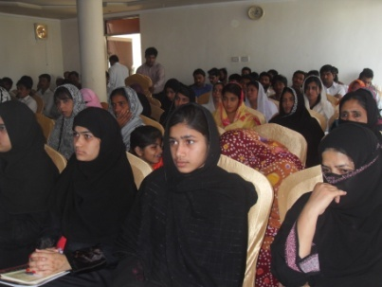
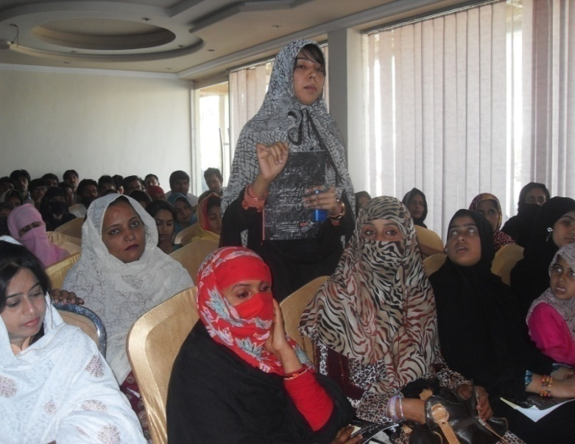

Mr. Yousaf Jalal Gill (Director Umeed partnership Pakistan) gave the detailed introduction to the theme of the seminar with reference to the National Education Policy 2009. He said religiously biased material should be removed from the text books used in Pakistan. Moreover, non-Muslim students should have an option of studying their religion, or ethics, as substitute of Islamic studies.

Mr. Mosa Saeed (Pakistan Peoples Party Ganva group) said that in Pakistan religion is used as a tool in politics. He also shared his views about social problems in Pakistan, such as the Shia/Sunni conflict. According to him industrial revolution is the solution to overcome these social issues. He further added that religion should be considered a private concern.

Major Shabir Ahmad Khan said that rights of non Muslims should be recognized at the level of government, society, and individuals He further said that Education reforms are urgently needed in Pakistan. Civil Society, government, and other stakeholders share an equal responsibility to raise issues regarding education policies.

Ms. Professor Sarfraz Batool ,(Islamya University Bahawalpur) said that religious minorities in Pakistan feel rejected. Religion is only one parameter of minority. Apart from religious minorities there are many other minorities in Pakistan i.e. Sindhi, Punjabi, Balochi, and Pathans. She explained the concept of Nation State refering to the community of people who share common language,culture, history, territory and government irrespective of their religion.

Mr. Inayat Kareem (Pakistan Tahreek Insaf) said that Education is a source which enables us to think; we as a nation need to do serious introspection on what impact education has made on the minds of society. Education reforms are urgently needed to give our graduates a competitive edge in the job market; we need to enhance the status of professional, technical and general educationists. Education is the major issue in Pakistan. Bangladesh and India are continuously upgrading and enhancing skills and education; Pakistan has yet to start.

Professor Rashid Rehmat (Bahawalpur Collage) said that we might have to be accountable for giving this generation such an education stuffed with so much religious discrimination. This kind of education is producing extremism, intolerance in the young minds, rather then making them responsible citizens with knowledge and skills. The result of this is an arrogant society.

Mr. Peter Jacob (Executive Director NCJP) participated in the seminar through Video link (Skype). He briefed about a meeting on OIC held in Lahore and shared his views and recommendations about 20 extra marks for Hafiz-e-Quran.

Mr. Yousaf Jalal concluded the session and shared the recommendations with participants.

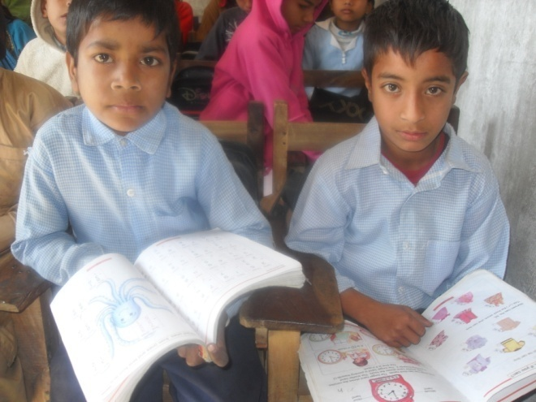
The communities among whom Umeed works have different biases, excuses, incorrect perceptions and taboos regarding education and training of girls. Working in these communities, Umeed takes into consideration the cultural and social practices being observed by them against women's education and training. Here are some of the taboos and Umeed’s responses:

1. "Some household decision makers give lower priority to girls’ education and training, especially if women’s remuneration is lower than men’s and employment opportunities are scarce."
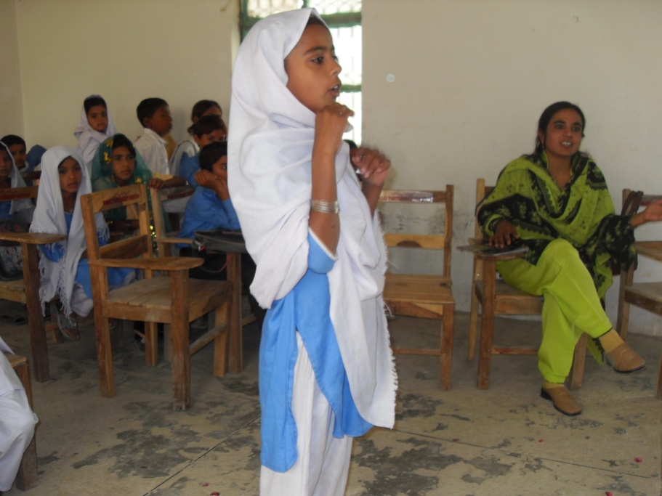
Due to this taboo these communities remain poor and backward because half the population (women) remain ineffective and become a burden on the other half. Umeed Partnership has broken this taboo by proving that given the opportunities, women are more productive, intelligent, studious, hard working and have ability to persevere, survive and tolerate in all circumstances. From its inception Umeed has been running adult education and skills training centres and two middle schools for girls. In schools boys are also getting education. Over the years girls’ education and skills training have been shown to be significantly more economically beneficial for their families than with men. Due to education and training these girls are running their own business, have good employment opportunities and run their own workshops and training centres.

2. "Girls are seen as relatively “transitory assets”, not worthy of long-term investment, as they leave their parents’ household upon marriage."

This is another taboo in communities in which Umeed works. Through this project Umeed has proved that investment in girls can be source of supporting the parental household as well as the husband's family. Many girls educated and trained by Umeed make their own dowry with their own earnings, pay for education of their younger siblings and look after their parents financially. Their respect and dignity are increased in the eyes of their families and after marriage they are equally respected by their in-laws. In many cases Umeed educated and trained wives become a source of financial support for their husbands.

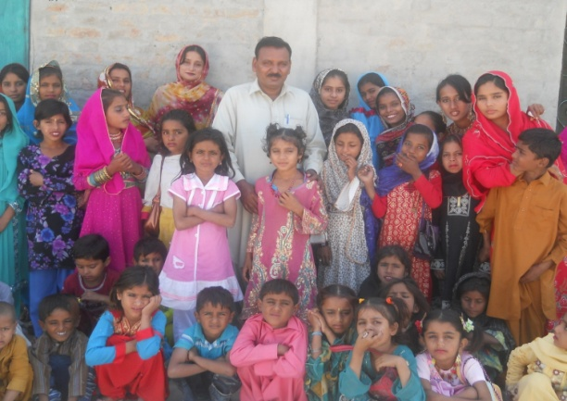
3. "Long distances to schools/training institutions, lack of public transport, lack of safe and accessible sanitary facilities as well as lack of female teachers and trainers. Male trainers and educators sometimes have discriminatory attitudes towards girls and women who often fear sexual harassment and insecurity in attending schools and training institutions. These are factors which can greatly impede female education and training in rural and slum areas."

Umeed started two middle schools in the midst of two colonies. Umeed provides skills training at the doorsteps of girls. The girls living in restricted environments do not have to travel and expose themselves to public unnecessarily. Instead they have schools and training in the safest family environment. Due to this their men folk also do not object to go to school or to follow the training. Umeed always respects the local culture and does not challenge the inappropriate cultural practices unnecessarily. Instead, Umeed believes that change in the environment provides opportunities to people to grow and develop who will change the bad practices of their own culture themselves. Its women who train women and no man is involved directly in the education and training, thus women have no fear of sexual abuse.

Over the years Umeed has gained sustainable results by going to the people instead of waiting for people to come to Umeed. Umeed believes that the factories should move to the places where raw material is available instead of transporting raw material to the factories. Under this strategy many girls whose lives were complicated with domestic affairs have received education and have become trained skilled workers or entrepreneurs. Living in closed cultures and unfavourable conditions created by men these girls were unaware of any way out until they joined the Umeed schools and training centres and became educated skilled workers.

4. "There are higher opportunity costs for girls’ education and training in most places. Education and training curricula and delivery are not always adapted to women’s learning needs”.

Both Umeed Middle schools and all skill training are free. Students do not pay a fee. Text books, stationery, study aids, uniforms or any other required material and tools are provided free of charge. Financially there is no burden on the families of the students. The whole curriculum is adapted according to students’ learning needs.
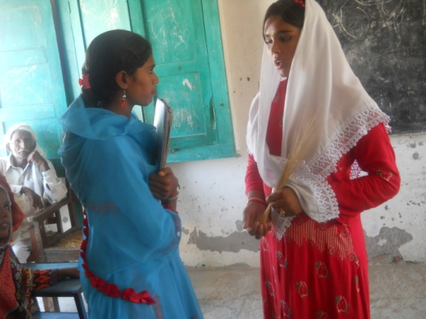
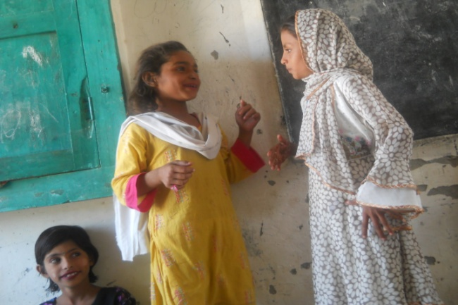

Umeed Middle Schools dedicated to Emma Marchant

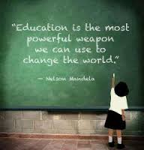
Dr. John Perkins and Lis Perkins are the force and spirit behind Umeed Partnership which has developed over the years to the present day where now women, street children and the youth of the most disadvantaged communities of Pakistan are benefiting from education, human rights training, skills developments and programs of small business and entrepreneurs. John and Lis are the founding members of Umeed Partnership UK. They, and other friends, have demonstrated dedication and commitment to promote the cause of the most disadvantaged and their unconditional love for the poor of Pakistan is beyond expression. Sadly, John and Lis’ daughter, Emma Marchant, died in January 2010 at the age of 33. In spite of this painful situation they continued working for Umeed. Looking at their services to the poor in Pakistan and to perpetuate Emma’s memory it was decided by the UPP Executive Board in their annual meeting 2013 to name and dedicate the Umeed Middle Schools at 18/BC Bahawalpur and 52/DB Yazman in the name of Emma Marchant. Thus these schools are now dedicated and named as the “Emma Marchant Umeed Middle Schools”.

EMMA MARCHANT’S LIFE HISTORY

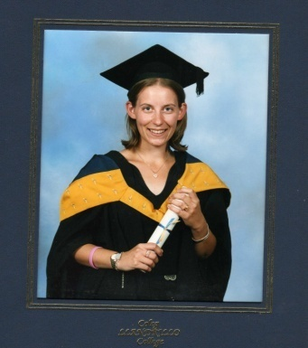
"...Emma was born as Emma Caroline Perkins in Bangor, North Wales, on 19 December 1976, the first (and only) child of John and Lis Perkins. Emma was baptised by her grandfather, an Anglican priest, in 1977 and was confirmed into the Anglican Church in Wales. She attended school on the Isle of Anglesey between the ages of 4 and 16 and continued to her Advanced Level subjects at Bangor College of Further Education. Emma met her future husband, Nick Marchant, in 1995 and between them they were proprietors of a whole food restaurant - Herbs - in Bangor. Their first child, Elliot William, was born in 1997 and Olivia Rose followed two years later.
Emma was industrious and, in addition to bringing up her children and working in Herbs, she secured a post in Bangor University, working as an administrator in Student Services and latterly in the Department of Psychology.

Emma and her family lived in a small upland community in Snowdonia, North Wales, in a 200-year-old stone built cottage with a few hectares of land on which sheep are reared. Emma understood the value of education and - in the course of the next few years - she was awarded a Higher National Diploma and a Bachelor's degree in Business Studies. Sadly, Emma's considerable potential was not realised; she suffered a lengthy debilitating illness in her early twenties and died at the early age of 33 in January 2010. Emma's legacy is personified in Elliot and Olivia, both of whom manifest her characteristics.

Emma was fortunate enough to receive an education and she used her opportunities wisely to provide a better life for her family and her community. It is fitting, therefore, that her name will be perpetuated by being given to the Umeed Middle Schools in Pakistan as an example of the benefits which can accrue through educating girls and women...."

Re-development of Emma Marchant Umeed Middle School

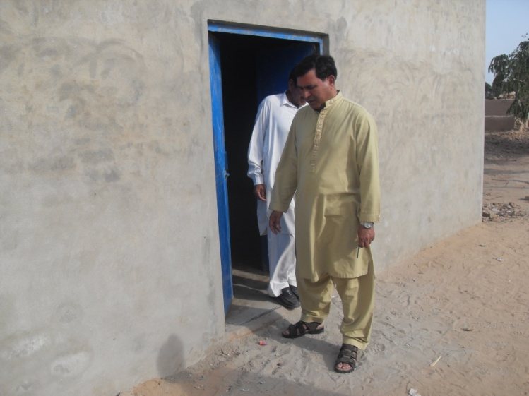
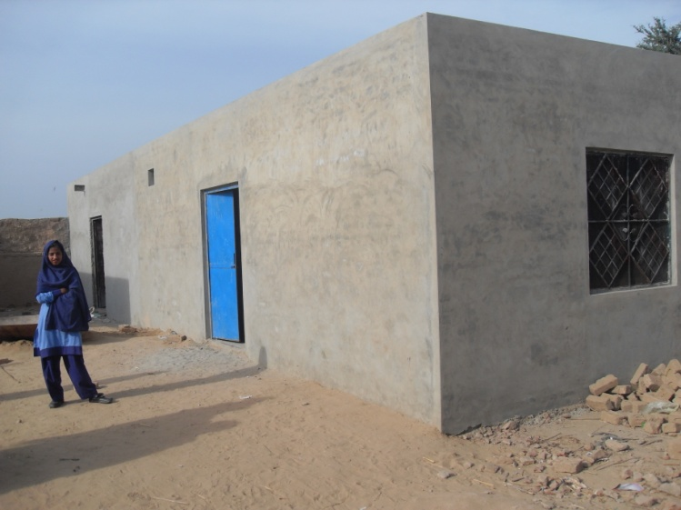
Rotary Clubs of Bangor and Prestatyn North Wales UK provided financial support for the re-development of Umeed Middle School at 52/DB Yazman. The following works were completed:

- Construction of two new classrooms
- Renovation of old classrooms: plastering walls, flooring, roofing and painting.
- Stage for students’ assembly and for community functions.
- Main steel gate for security
- Toilet (with septic tank) for staff and students
- Hand pump installation for potable water
- Renovation of boundary wall, levelling the ground and planting trees.

Thanks to both the Clubs for their generosity and thoughtfulness.

Education Committee visited the Umeed Schools

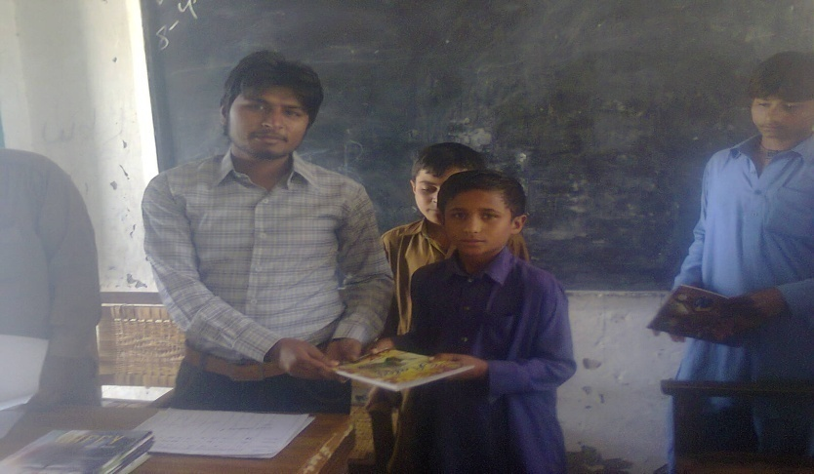
On Saturday morning 5th January, 2013 at 10:00 AM the Umeed Education Committee (Shamim Gulzar Headmistress, Yousuf Gill Coordinator and Ado Raam Supervisor) visited Umeed Middle School 52/DB Yazman and at 1.00 PM visited Umeed Middle School 18/BC Bahawalpur

Students were assessed orally as well as using writing boards. Behaviour was satisfactory but some drawbacks were observed while assessing their standard of learning which were immediately brought to the teachers’ attention. The following actions were to be initiated immediately:

- Phonics teaching methods should be started
- Medium of instruction should be in English.
- Teaching methods should be innovative and made interesting for the students.
- Full stress should be given on handwriting, reading and speaking.
- General knowledge should be taught and assessed weekly.
- Weekly tests should be continued in all subjects on a rotational basis.
- Teachers should come to school well prepared.

Final examinations, results, books, stationary and uniforms distribution
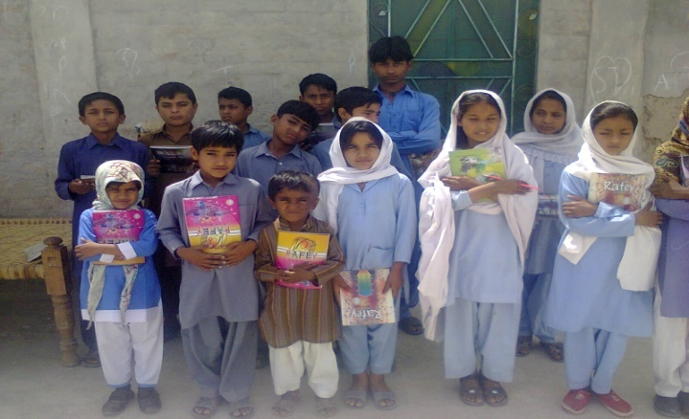
Prior to the final examination Yousuf Gill Director UPP, Azim Gill manager education and Ado Ram Regional supervisor visited the Emma Marchant Umeed Middle Schools 18/BCBahawalpur & 52/DB Yazman from 4th - 8th April 2013. After the staff meetings and inspection of the Schools Yousuf left the two members to continue the examinations and preparation of results. The Director stressed the following points in the staff meetings:

- The standard of education should be exemplary to attract and serve more students in the area. Apart from education there is an acute need to stress extracurricular activities i.e. games, debates, art work, poetry, stage shows etc.
- Monthly parent/ teacher meetings should be held
- The final exams will be held under the supervision of Umeed administrative staff.
- The results will be announced immediately after the exams by the Umeed administration staff.
- Text books, exercise books, stationery and uniforms will be provided to all students by Umeed immediately after the results.
- It is important for School staff that they open bank accounts to receive their salaries.
- It was decided that staff will pay an Umeed membership fee of Rs.00 monthly.
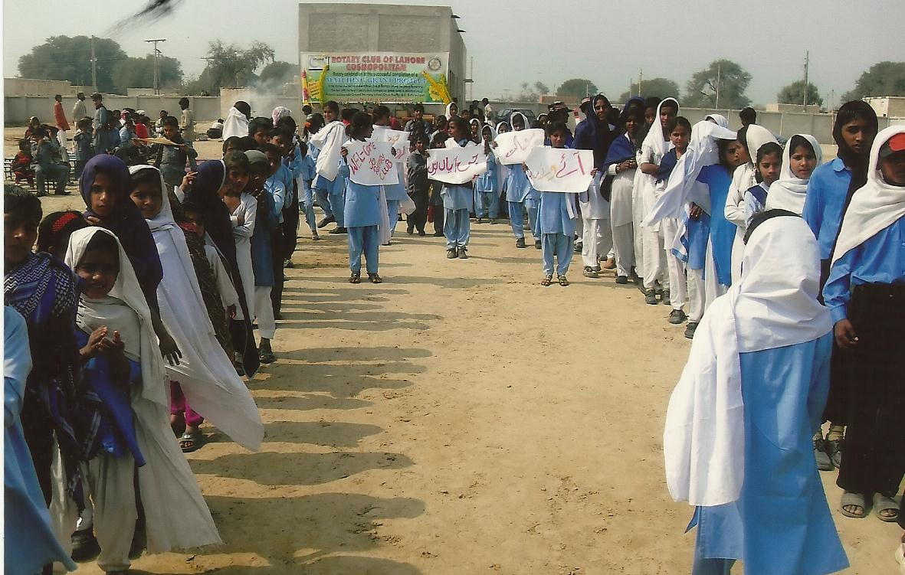

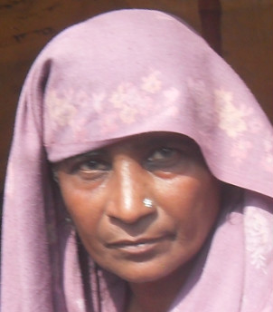
The Umeed Legal Aid Forum works mainly in Cholistan for the marginalized communities. Umeed is providing legal aid mainly in the cases of women in distress. With the help of its legal advisors Umeed has recently taken up a case where a husband severely disfigured his wife in one of the villages in Cholistan desert. Umeed is also dealing with a rape case of a teenage girl in the area of Yazman.

Umeed intervened in a case of a Hindu MBBS Medical officer in the area of Liaquatpur where he was persecuted and threatened with death by his own staff because he prevented them from stealing medicines from the medical centre. He was pressurised to vacate the post as soon as possible. He was a sincere and hard working officer. The medical officer was persecuted by his own staff only due to his religion - it is almost a curse to be a Hindu in Pakistan.

Umeed also provided help to the Hindu community living in a Hindu colony near Bahawalpur whose settlement was about to be demolished by powerful landlords. These land lords brought bulldozers; hundreds of people gathered to demolish the houses and evacuate the Hindu community from that colony. The landlords’ view was that the Hindus are living illegally on the land thus they should leave the place so that they may distribute the land among their own people. Umeed intervened with the help of higher authorities and saved the Hindu colony from annihilation.

During 2012-2013 the Umeed Legal Aid Forum provided aid in four court cases of forced conversion which took place mainly in the Yazman area. From village 68/DB Yazman a Christian girl was abducted and forced to marry a Muslim man. From different Hindu families three girls were abducted and were forced to embrace Islam and marry Muslim men. (Detailed reports are available).
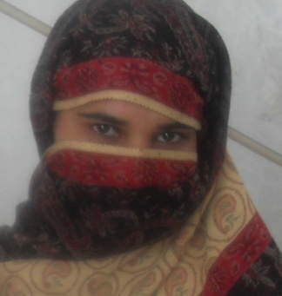
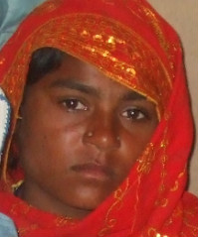
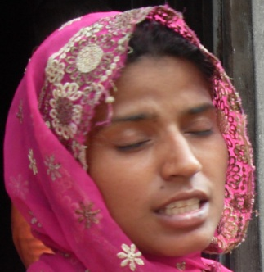

“Wherever men and women are persecuted because of their race, religion, or political views, that place must at that moment become the centre of the universe.”
Elie Wiesel

Umeed Partnership Pakistan (UPP) works in collaboration with other likeminded organizations.

USAID Gender Equity Program

USAID Gender Equity Program of Aurat Foundation, Lahore, organized a two day training workshop from 19-20 September 2012 at Hotel Sun Fort, Liberty Market, Lahore. The theme of the training was Branding, Marking and Case Study Writing. One representative from each partner organization of GEP Cycle 7 was invited to participate in this training session. Yousuf Jalal Gill Director UPP attended the training.
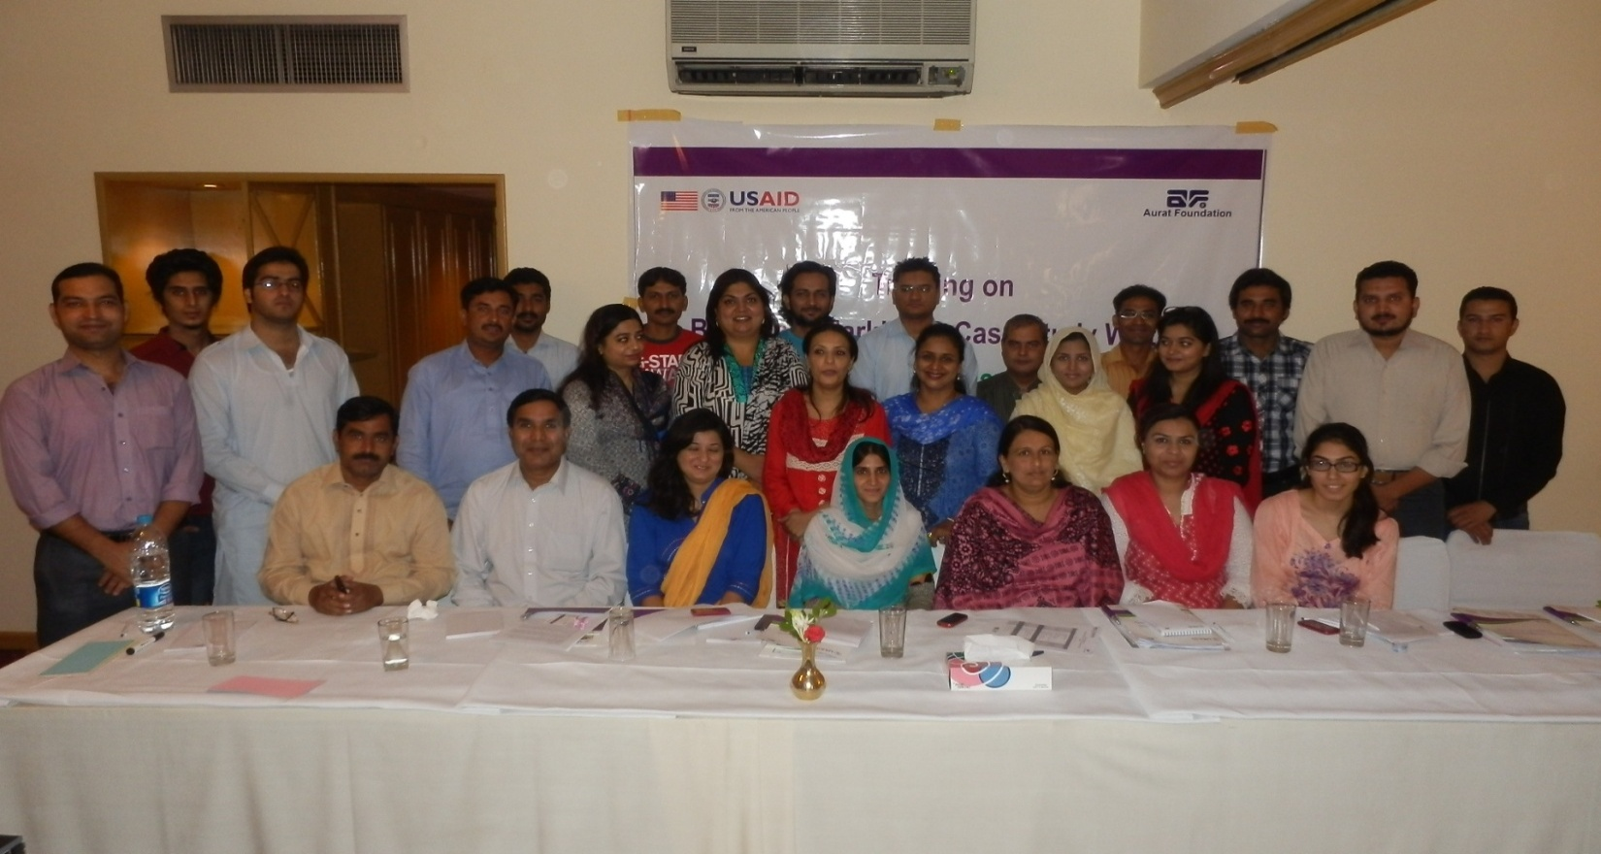
Distribution of emergency relief
Umeed staff participated in the program organized by Mass Media Organization Faisalabad to distribute the emergency relief in the form of bags of flour, sugar, cooking oil and lentils etc. among the affected people of St. Joseph Colony Badami Bag, Lahore on 18th April 2013 at Lahore Caritas Office Lahore. Miss Romana Bashir from Rawalpindi was the chief guest and Yousuf Gill, Director UPP and Rev. Fr. Iftekhar OP from Faisalabad were the main speakers. The speakers emphasized the need to promote peace and harmony in the country. Malcolm Arslaan, the director of Mass Media Organization, and his counterpart, also participated.
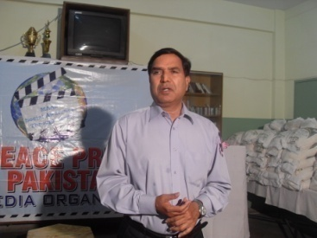
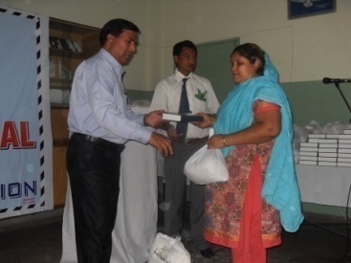
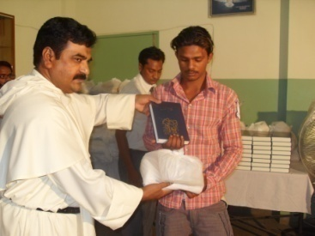

Meeting with AWAZ (Community Support Organization) Bahawalpur
A joint meeting of Umeed staff and AWAZ Organization’s personnel was held at AWAZ office Bahawalpur to discuss the possibilities of organizing Human Rights trainings, seminars and skill trainings for women. During this meeting a preparation was done for one day seminar hosted by Umeed in cooperation with National Commission for Justice and Peace (NCJP) on 4th April at Panda restaurant Bahawalpur. The theme of the seminar was “Education reforms and responsibility of political representatives”. Grateful thanks to AWAZ for all its cooperation and service.
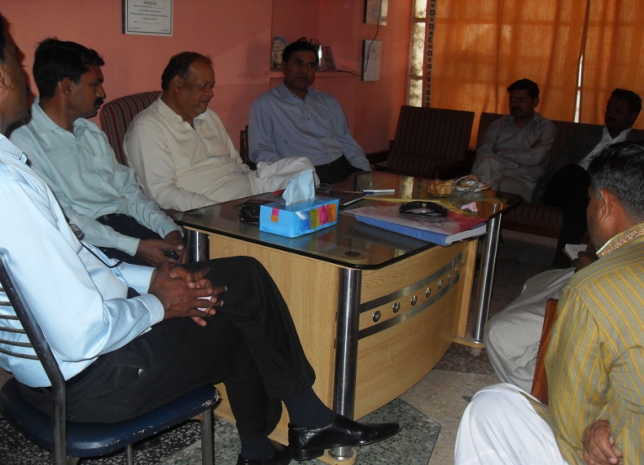
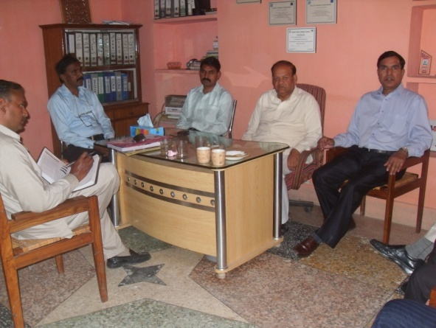

Christian homes burnt and plundered over blasphemy row in Lahore.
The administration of Umeed Partnership visited Joseph colony on 11th and 12th March to see the damage and to review the situation of the affected people. There were heartbreaking scenes at the site. Men, women and children whose houses were turned into heaps of black charcoal were distressed.
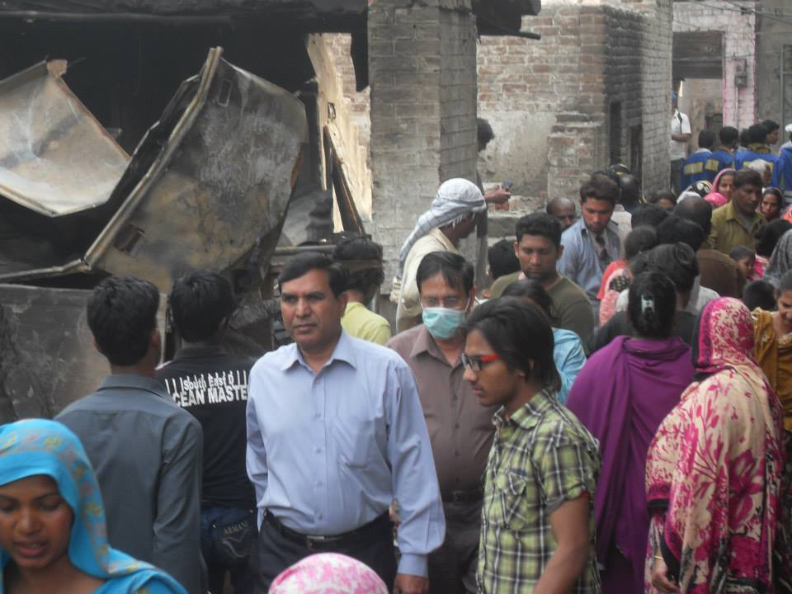
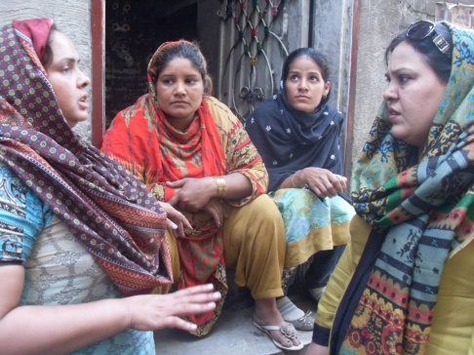

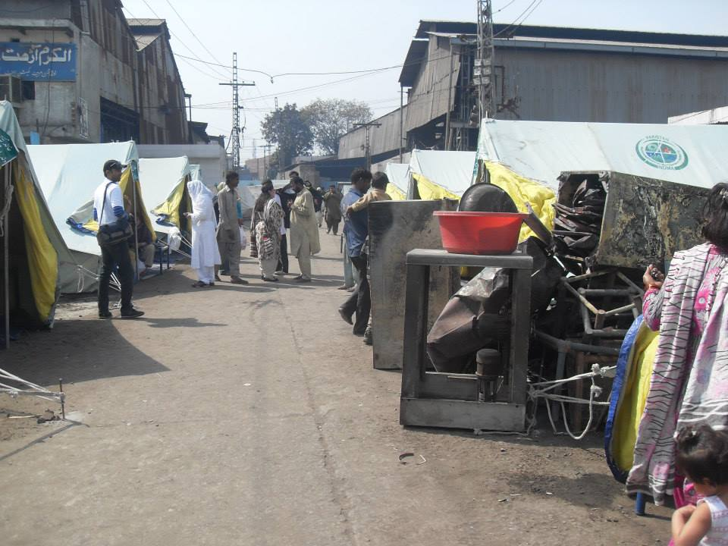
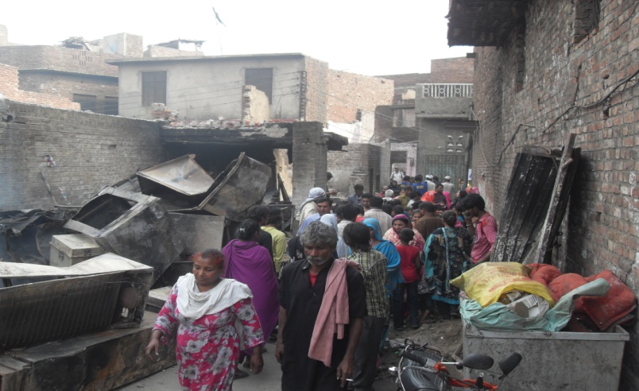

Umeed is a partner of Awaz-e-Haq Ittehad (Voice for Rights Coalition) a coalition of 13 organizations and NGOs works on serious national Human Rights issues under the umbrella of MM Partners Netherlands.

Meeting at Multan

The meeting of Awaz-e- Haq Itehad was held on April 24 2012 at National Office of Justice and Peace Commission Multan. This meeting was attended by all the 13 members organisations of the MM partners. The participants reviewed the progress on the decisions of the last meeting of December 13-14 2011 in Lahore. With a main observation that a realistic view should be taken especially while assigning responsibilities and making commitments. After detailed deliberations the Awaz-e-Haq Itehad members agreed to work on the two specific issues: i.e. hate (religious) material in the curriculum, forced conversion of minorities and their general situation.

Meeting at Multan

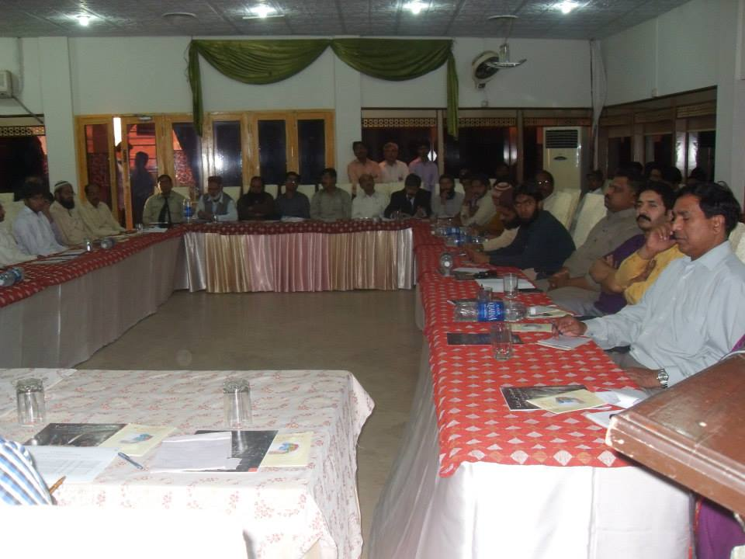
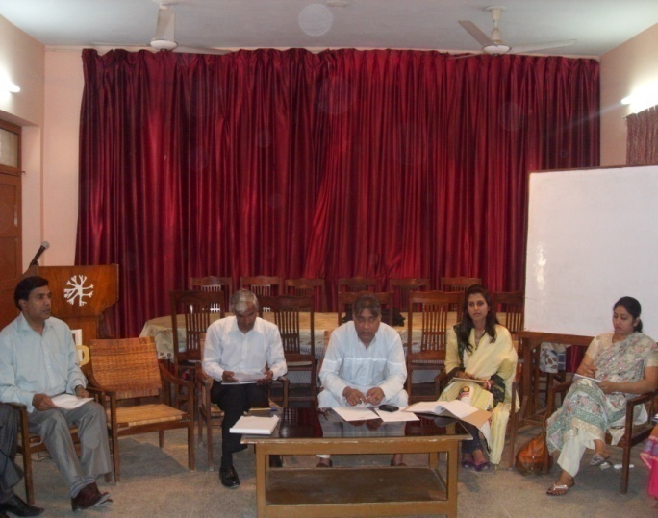
The meeting of Awaz-e- Haq Itehad was held on March 25 2013 at National Office of Justice and Peace Commission Multan. This meeting was attended by all the 13 member organizations of the MM partners. Mr. Peter Jacob welcomed the participents and gave resume of the project and AHI. He also briefed about some recent developments regarding NCJP campaign on curriculum reforms. Mr. Yousuf Jalal Gill, Mr. Shafiq Sharif, Mr.Younis Alam, Mr. Adnan Hayat and Mr. Ayub Sajid shared their analysis about socio-economic situation of the country, other participents also gave their inputs regarding current situation of the country. Participants of the meeting also did a training need assessment as a result some traning needs were raised. Towards the end of the meeting some responsibilities were distributed among the participants.
Conference at Multan
The conference was organised under the banner of Awaz-e-Haq Ittehad by Organisation for Development and Peace (ODP) Multan with collaboration of National Commission for Justice and Peace on “religious biases in education system and text books” on Monday 25th March 2013 at Sheza Inn Multan. More than 100 people from all walks of life participated in the conference. The speakers gave enriching inputs and stressed the need to bring reforms in curriculum as soon as possible. Special thanks and congratulation goes to ODP for doing good job. Two members from Umeed Partnership Pakistan (UPP) Lahore participated in the conference.

Meeting at Sargodha

The meeting of Awaz-e- Haq Itehad was held on April 24, 2013 at Sargodha. The meeting was attended by most of the members organizations of the MM partners. A detailed discussion was held about, criticism on the title of publication” Educaiton vs Fanatic Literacy”. Mr. Peter Jecob concluded the discussion by saying that there are always some reactions to art and paintings world over. He said some art can be disturbing because it reflects painful reality but we should face such criticism with positive approch.

Ms. Aksa Kanwal did a context analysis of Pakisatan, election scenarios poverty, economic unstability, low litracry rate, politcal unstability, corruption, population explosion, international influence on Pakistan, trade loss, power crisis, industrialization decline, Musharraf’s trial and role of care taker government in Musharraf’s trial, growing democracy, some revolutionary legislations, (18thamendment, and law about sexual harassment) were disucssed in the context analysis.
Participants in the meeting decided to change the format of the activities in order to avoid the repetition of activities and make them more productive and result oriented, new format would be rally or a workshop instead of seminar or conference.
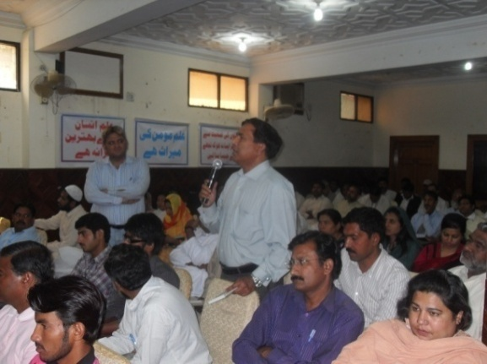
Seminar at Sargodha
Ezaz-e-Niswan Organisation and Taang Wasaib Organisation Surghuda under the umbrella of Awaz-e-haq Itehad organised a seminar on “Education Reforms and Role of Political Representatives” on 24th April 2013 at Solo Hotel Sargodha. Representatives from all the organisations of Awaz-e-haq Itehad along with people of Sargodha from different walks of life participated in the seminar. The input was very encouraging and the open forum made it very practical. Umeed being the part of Awaz-e-haq Itehad participated in the seminar. Thanks and congratulations to both the organisations for organising such meaningful seminar.

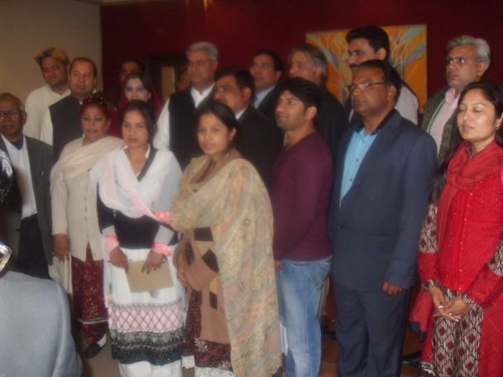
Meeting at Faisalabad
The meeting of Awaz-e- Haq Itehad was held from 16-17 February, 2013 at Arooj-e- Mariyum Catholic Church Faisalabad. The meeting was attended by most of the members organizations of the MM partners. A session was held on SWOT exercise. During SWOT exercise all participants gave their inputs regarding socio-political situation of the country. Mr. Kashif Aslam (NCJP) facilitates the session and gave a presentation on “Campaign for unbiased education”. He briefed about some recent developments and last eight months activities regarding campaign. It was decided that:
- AHI will have a logo and Facebook page.
- A desk or office of AHI will be created at NCJP Lahore that will finally become a secretariat.
- A diary or calendar of AHI will be printed, as a campaign material.
- Prepare an activity chart for AHI.
- Social and electronic media will be used to spread the campaign message.
Towards the end of the meeting some responsibilities were distributed among the participants.
Meeting at Faisalabad
The Partners Networking meeting was held on April 15, 2013 at Arooj-e- Mariyum Catholic Church Faisalabad. The meeting was attended by most of the member organizations of the MM partners. Meeting started with the topic of Election 2013 in Pakistan, role of Media, political parties, NADRA, Police, and Faffan’s (free and fair election network) observation. Participants discussed the performance of Political parties and public during election. Their are many positive things happened in this election e.g. citizens cast there votes with interest and responsibility, women turn out is tremendous and overall turn out was 60% according to Election Commission of Pakistan. Beside this, some unpleasant incidents of ragging in some polling stations were reported by the media also. The people of Pakistan are curious to know does the next prime minister have abilities to counter the challenges of International Monetary Fund (IMF), rising terrorism and Load shedding and the disrupted economy in the country. Mr. Peter Jacob shared a presentation on Education Ministry, its Function and Advocacy.
- The preparation and maintenance of syllabus is the responsibility of authors or educationists, it’s not the mandate of National Assembly.
- Curriculum is an outline in which the educationists maintained the syllabus, learning objects, policy and its implications. In education system policy must revised every year.
- Everybody has the right to take any information from education department.
- There is need to develop higher education and research centers in Pakistan not on primary or middle level but even at universities level.
- Raise the Privatization for funding in education sector for Monitoring and trainings of faculty of education department.
- Remove the Discriminatory laws from the education system like 20 extra marks for Nazra Quran.
Towards the end of the meeting some responsibilities were distributed among the participants.
Meeting and Rally at Faisalabad
The Partners Networking meeting and rally was held from 15-16 May, 2013 at Arooj-e- Mariyum Catholic Church Faisalabad. The meeting was attended by most of the member organizations of the MM partners. On 16 May 2013, Awaz e Haq Ittehad Network in collaboration with Association of Women for Awareness and Motivation (AWAM), Arooj e Marriam Catholic Church (AMCC) and National Commission for Justice and Peace (NCJP) organized a rally near Faisalabad Press Club. Around 65 persons form different walks of life participated in the rally where press release was submitted. 11 newspapers have covered this event. Umeed staff played an active role in the meeting as well as in the rally.
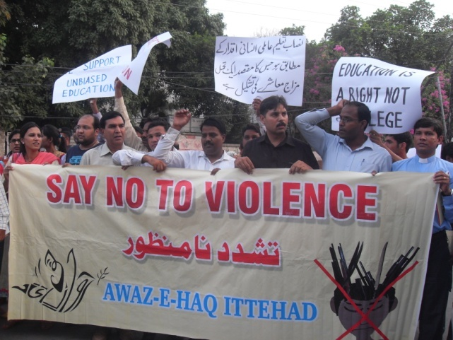
Meeting and Rally at Lahore
The Partners Networking meeting, conference and rally was held from June 25-26, 2013 at Lahore. The meeting was attended by most of the member organizations of the MM partners. On 26th June 2013, Awaz-e-Haq Ittehad coalition organized a rally in Lahore near Lahore Press Club. 70 Persons participated in the rally. A press release was submitted to different news groups, the rally got coverage in 5 main stream newspapers. The purpose behind these rallies was to demand from the government for the positive educational reforms in the current syllabus, and eliminate the discriminatory and hate material. Umeed staff participated in all the activities.

Visitors and Guests
Mrs. Corien Waheed visited Umeed Head Office

Umeed
Guests & Visitors


Mensen met een Missie of Netherlands is supporting about 15 partner organisations in Pakistan, as well as the MM partner network,(Awaz-e-Haq Ittehad) of which all partners are part. Mensen met een Missie asked Mrs. Corien Waheed of Lahore to visit 13 partners, all in Punjab province, to talk with the staff members and the director of each partner organisation for a couple of hours about the organisation of each NGO. Corien carried a checklist which she used to frame the discussion. The meeting was intended as a moment for learning and reflection; it was not an assessment of each organization. It was rather to encourage the administration of each organisation to use this opportunity to see where they are and to discuss what they as staff think was needed to further develop their organisation.
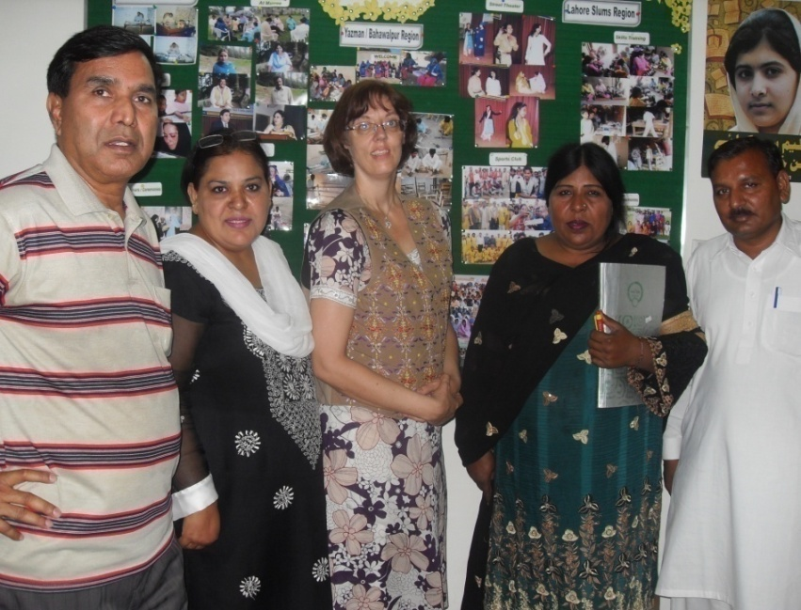
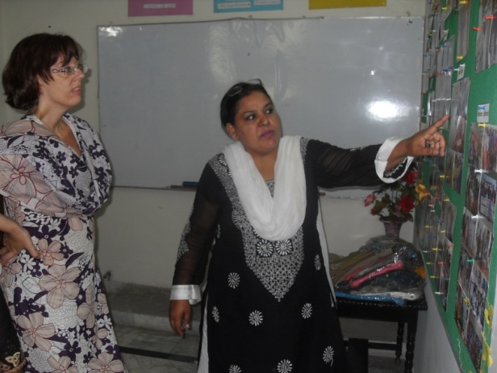
Corien Waheed visited the Umeed Head Office Lahore on 21st May 2013. She spent almost a day with the Umeed staff. She had discussions with the staff and shared her experience in the field of development. Her visit was judged to be fruitful and inspiring for the Umeed staff.

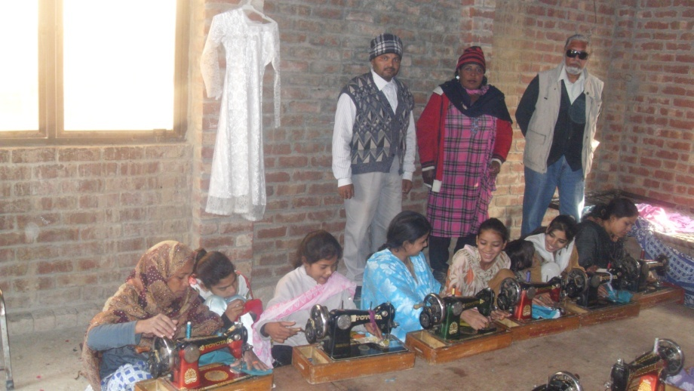
Mr. Sheikh form Denmark visited the
Umeed Project

Mrs. Mona Sheikh from Denmark wished to help
the Umeed women trainees in embroidery and sewing
by giving them work from her country since she
was planning to open boutique. In order to see the quality of work and to meet women in the Centres, her father Mr. Sheikh, who was also touring Pakistan, visited the Centres He was impressed with the work and discussed with the women on how to go about doing work for them. Mona Sheikh still has yet to open the boutique, but when she does she will offer work to the Umeed trainees.

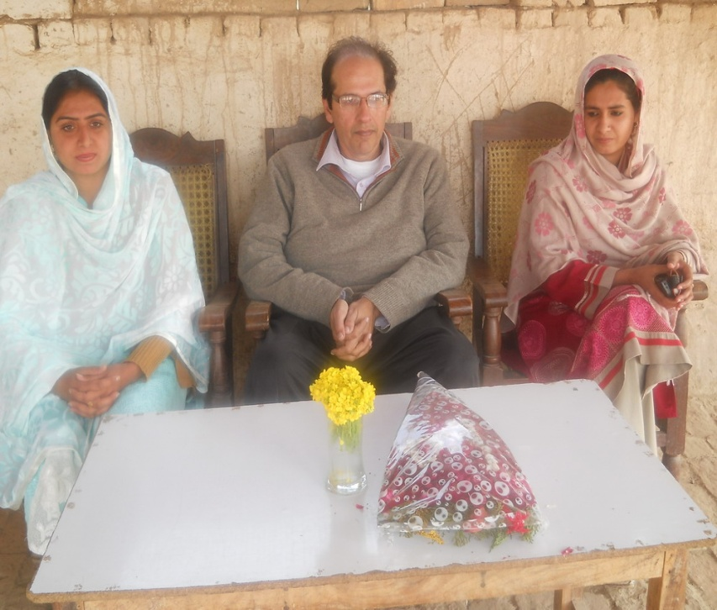
Umeed Education Project: Visit by a Rotarian

During December 2012 Rotarian Nadeem Mazhar of
The Rotary Club of Lahore South visited the Umeed
Education Project in Bahawalpur/Yazman region. He visited both Emma Marchant Umeed Middle
Schools exploring the possibilities of organizing
matching grant to upgrade the school.

Where we work
Lahore Slums
Umeed skills training centres for women and street children
Human Rights Training Sessions

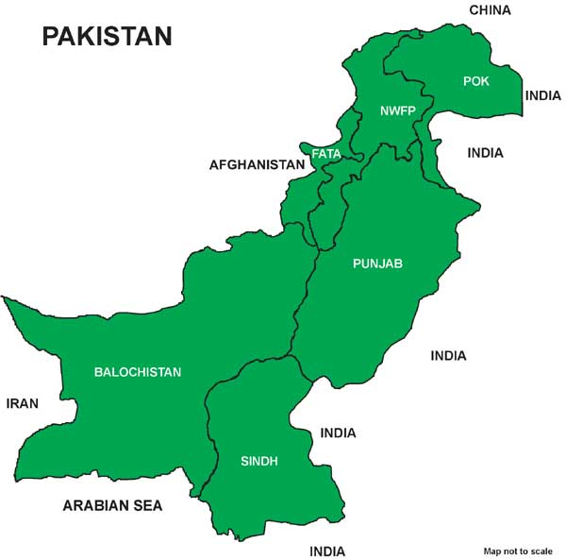

Quetta/Loralai
Umeed skills training centres for women
Human Rights Training Sessions

Bahawalpur/Yazman
Umeed skills training centres for women and street children
Two Middle Schools for boys/ girls
Human Rights Training Sessions
Legal Aid Forum

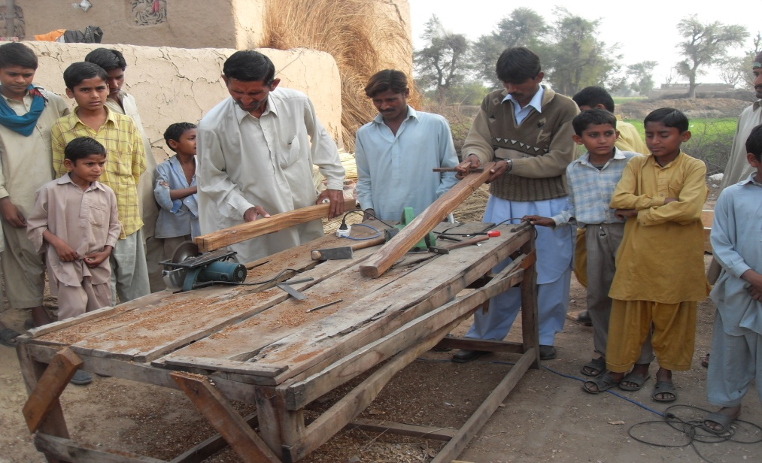
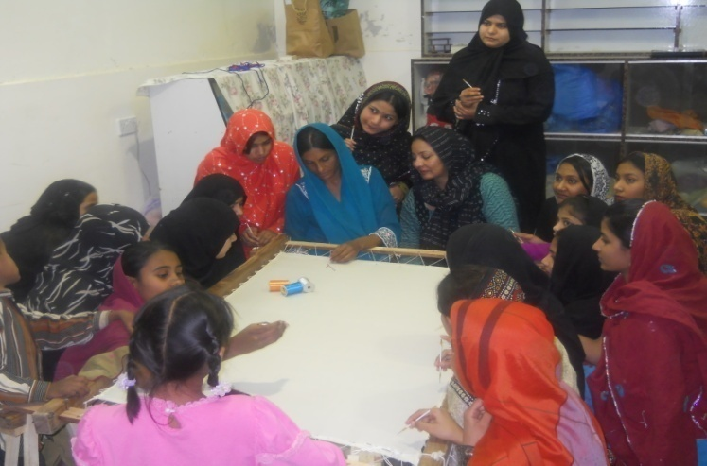
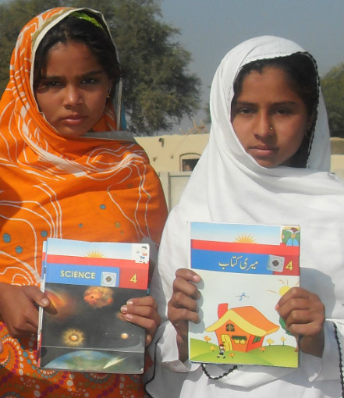
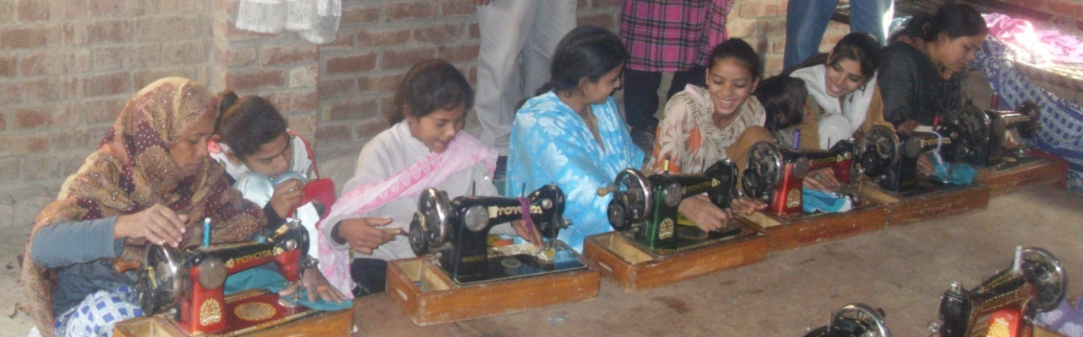
Come and join Umeed:
Become partners of Hope
Hope for a better and just world;
Hope for men and women’s equality;
Hope to strengthen the hopeless and those in despair.

Join us to support our program of
Human Rights Training for women and street children (Just Society)
Economic freedom for women and street children (vocational)
Girls’ & boys education (schools)
Rehabilitation of women in distress (legal aid)
Talent Development (Youth)

Help Umeed in providing:
Administrative and skills-based support
Tools and materials (in-kind)
Financial support
Support as volunteers

(Operational and Financial transparency is guaranteed).

Visit or write to us:

Yousuf Jalal Gill
Executive Director and Founder – UPP
House no. 198/199 block J-3, M.A. Johar Town, Lahore Pakistan.
Tele: 0092 42 35957302, Cell 0092 300 9444482
umeedpartnershippakistan@gmail.com
yousufjalal22@yahoo.com

John Perkins
Chair, Umeed Partnership (UK)
"Gwyndy", Hill Street, Menai Bridge
Anglesey, LL59 5AD, United Kingdom
0044 (0)1248 712389, 07547 730 495
john@justshopping.co.uk
www.umeepartnership.org.uk

